Dimensional Analysis

- Conversion factors are used to manipulate units:
- Desired unit = given unit × (conversion factor)
- Conversion ratio is equivalent to multiplying by ONE
- The conversion factors are simple ratios:

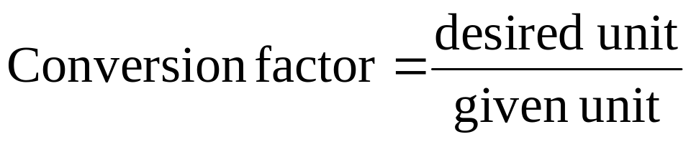

Using Two or More Conversion Factors

Example to convert length in meters to length in inches:
