Famous Conversion Disasters!

23 September 1999
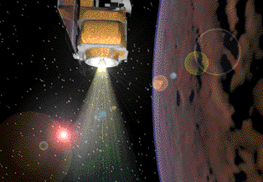
When controllers at JPL fired the Mars Climate Orbiter's thrusters to tune its orbit, the 125 million dollar-spacecraft descended into the Red Planet's atmosphere and was torn to pieces. Engineers at Lockheed had given JPL the strength of the thrusters in pounds-force. JPL assumed the data was in newtons. One pound-force is about 4.45 newtons, so the controllers had given the Orbiter a push more than four times stronger than it should have been.

23 July 1983
Air Canada Flight 143, a brand-new Boeing 767, was flying between Montreal and Edmonton when first one, then the other engine quit. The plane was out of fuel. Airliners measure their fuel requirements by mass, not volume. In Montreal, mechanics had measured the volume of fuel in the tanks, 7,682 liters. The pilot knew he needed 22,300 kilograms of fuel to get to Edmonton, and asked the mechanic what was the factor for converting liters into kilograms. The mechanic answered, "1.77." So 7,682 times 1.77 is 13,597 kilograms. Taking that away from the 22,300 kg needed gives 8,703 more kilograms needed. Divide by 1.77 to convert the 8,703 kg to 4,917 liters. They added that much fuel and double-checked it.
Unfortunately, nobody double-checked the conversion factor. The 767 was the first all-metric plane in the fleet, the first whose fuel requirements were stated in kilograms, not pounds. "1.77" sounded right--that is, familiar-- because it is the number of pounds of fuel per liter, not the number of kilograms per liter. A liter of jet fuel weighs about 0.803 kilograms; the pilots had actually needed to add 20,163 liters.
One of the pilots knew of a nearby abandoned Air Force base. The other was an experienced glider pilot. With no power, he managed to glide 22 miles and land the plane in the midst of Family Day--the runway had been converted to a drag-strip. No one was seriously injured, and the Winnipeg Sports Car Club put out a fire in the nose with dozens of hand-held extinguishers. Air Canada immediately dispatched a team of mechanics. Their car ran out of gasoline on the backroads.

