- Molecular compounds are made of molecules.
  - each molecule contains anywhere from two atoms (diatomic molecules) to thousands (biological molecules).
  - each molecule has the same element composition and properties as the compound.
  - synonym: covalent compound
Examples:

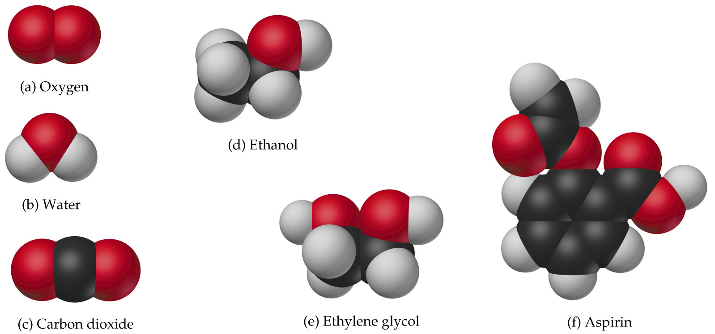
- Ionic compounds are made of positive ions (cations) and negative ions (anions).
  - cations combine with anions in just the right numbers to give an electrically neutral compound.
  - metals form cations easily, and nonmetals form anions, so metal/nonmetal compounds are often ionic
  - cations and anions pack into orderly arrays in solids; they become mobile when the compound melts
an ion pair | 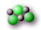  an ion cluster | 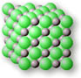  an ion crystal
  - examples: NaCl, KBr, Na₂S, MgBr₂
  - synonym: salts

