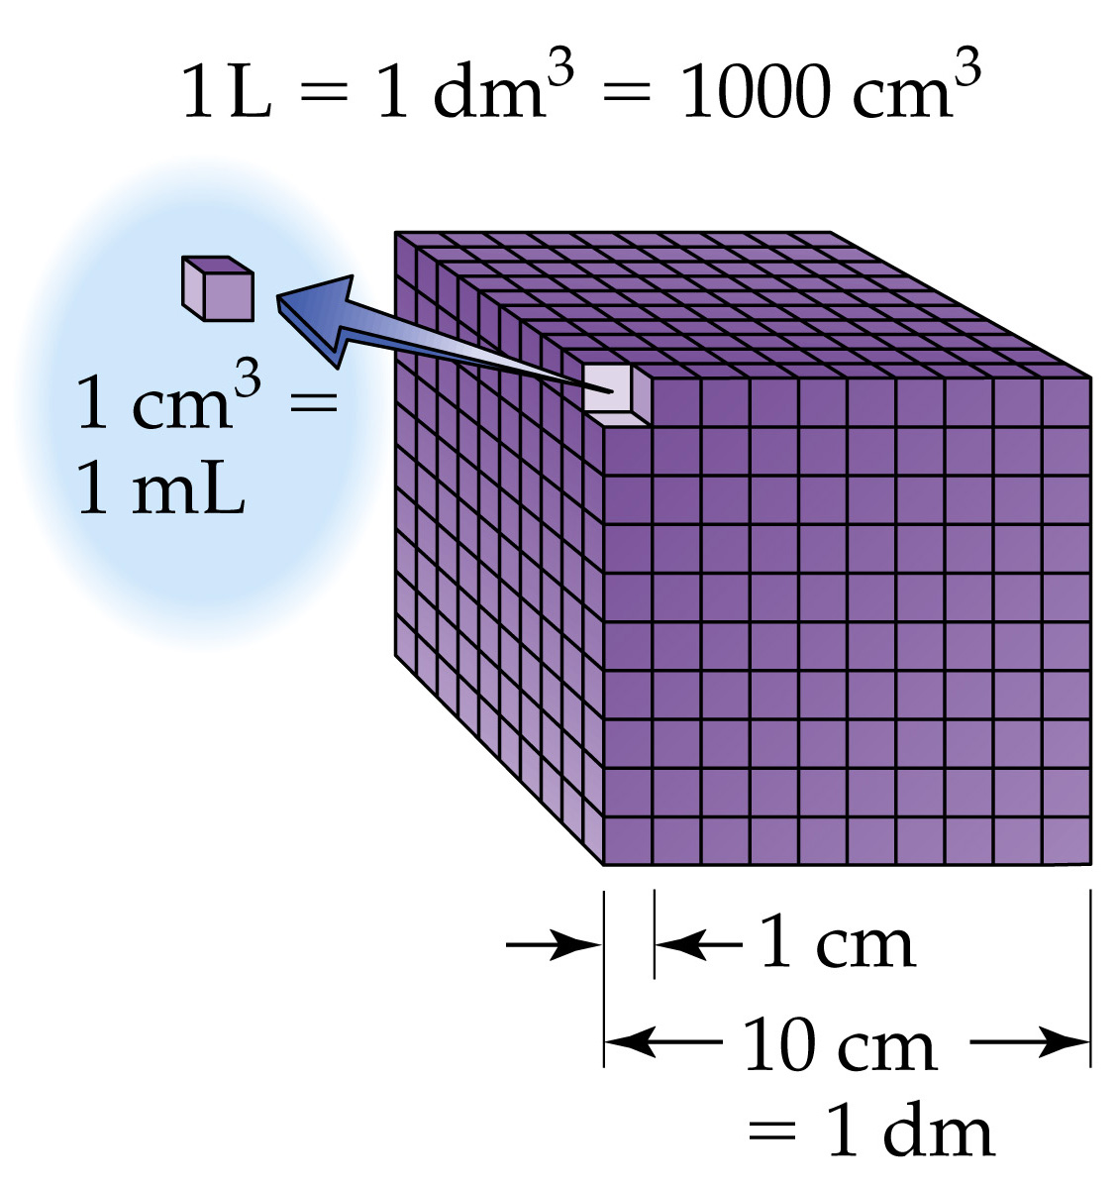

The units for volume are given by
(units of length)³.

SI unit for volume is 1 m³.
But we can use 1 mL = 1 cm³.
So 1000 mL = 1000 cm³
Or 1 L = 1000 cm³

EQUIVALENT volume units:
1 L = 1 dm³ = 1000 cm³ = 1000 mL
or
1 mL = 1 cm³

