States of Matter

Some Characteristics of Gases, Liquids and Solids and the Microscopic Explanation for the Behavior
GAS | LIQUID | SOLID
assumes the shape and volume of its container  particles can move past one another | assumes the shape of the part of the container which it occupies  particles can move/slide past one another | retains a fixed volume and shape  rigid - particles locked into place
compressible  lots of free space between particles | not easily compressible  little free space between particles | not easily compressible  little free space between particles
flows easily  particles can move past one another | flows easily  particles can move/slide past one another | does not flow easily  rigid - particles cannot move/slide past one another

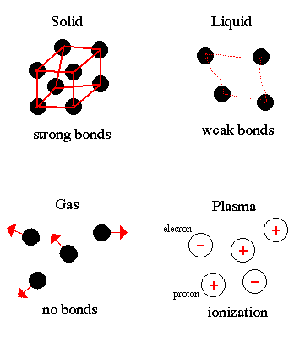
Plasmas are only found in the coronae and cores of stars.

