The Temperature-Volume Relationship: Charles’s Law

We know that hot air balloons expand when they are heated.

Charles’s Law: the volume of a fixed quantity of gas at constant pressure increases as the temperature increases.

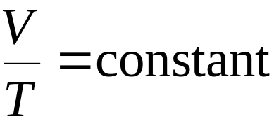Mathematically:

