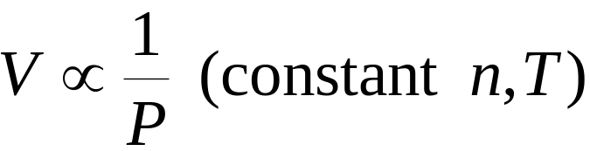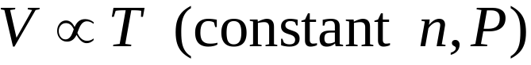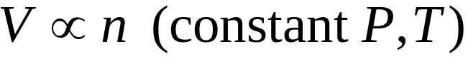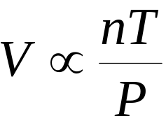

•We can combine these into a general gas law:

The Ideal Gas Equation
- Boyle’s Law:
Charles’s Law:
- Avogadro’s Law:

