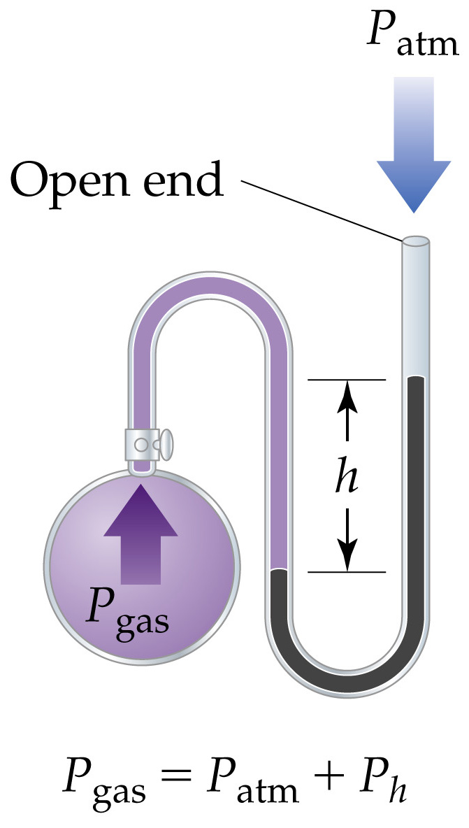

Atmosphere Pressure and the Manometer

- The pressures of gases not open to the atmosphere are measured in manometers.
- A manometer consists of bulb of gas attached to a U-tube containing Hg:
If P_{gas} < P_{atm} then P_{gas} + P_{h2} =P_{at}
If P_{gas} > P_{atm} then P_{gas} = P_{atm} + P_{h2}.

