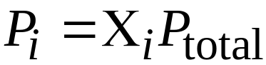

Combing the equations
P_{total} = ( n₁ + n₂ + n₃ + …) (RT/V)

Partial Pressures and Mole Fractions
Let n_{i} be the number of moles of gas i exerting a partial pressure P_{i}, then

where Χ_{i} is the mole fraction (n_{i}/n_{t}).
Gas Mixtures and Partial Pressures

