Pressure is the force acting on an object per unit area:

Gravity exerts a force on the earth’s atmosphere F= m*g
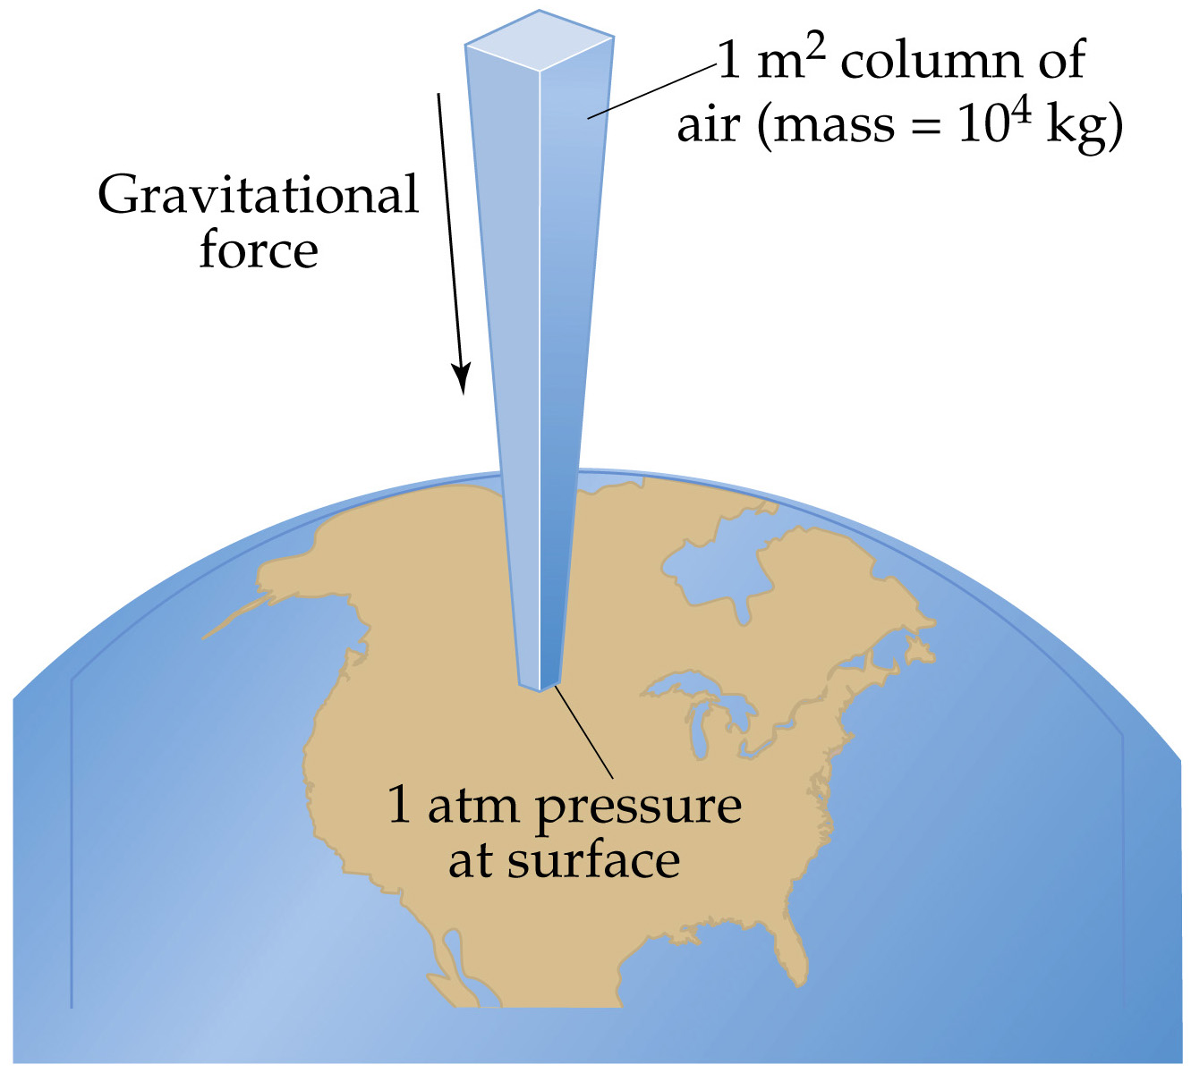
A column of air 1 m2 in cross section
exerts a Force:
F= 10⁴ kg*9.8m/s² ≈ 10⁵ N.
(10,340kg*9.8m/s² = 1.014 x 10⁵ N)

The Pressure of a 1 m2 column of air
is close to 10⁵ N/m² = 10⁵Pa =100 kPa.

