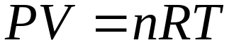If R is the constant of proportionality
(called the gas constant), then The ideal gas equation is:

