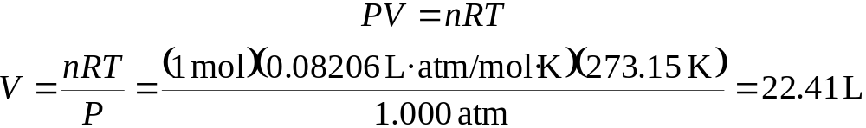

We define STP (standard temperature and pressure) = 0°C, 273.15 K, 1 atm.

Volume of 1 mol of gas at STP is:

(this translates to a cube approximately 11 inches on a side)

