Overview

In this chapter we will build upon concepts introduced in Brown Chapter 5 (Thermochemistry). Please take some time to review state functions, the first law of thermodynamics, enthalpy and internal energy.

In this chapter we will learn what determines the extent of a reaction. Thermodynamics is a powerful tool in chemistry, physics and engineering. In chapter 14, we learned about how fast reactions occur, in this chapter we will learn how far a reaction will go. Keep in mind that kinetics and thermodynamics are pretty distinct. Thermodynamics is about the equilibrium concentrations of products and reactants and tells us nothing about how fast equilibrium is reached. Kinetics tells us how fast a reaction will occur, but doesn’t tell us the extent or direction of a reaction.

Enthalpy of reaction (ΔH_{rxn}): heat transferred for a reaction performed at constant pressure (open to the atmosphere).

First Law of Thermodynamics: ΔE = q + w; this is conservation of energy. There are two ways to change the amount of energy of a system: heat (q) or work (w). The change in internal energy (ΔE) equals the heat transfer plus the work transfer.

State function: parameters that depend only upon initial and final states, independent of path. Common example of a state function: altitude. Thermodynamic state functions: internal energy (E), enthalpy (H), volume.

  - Spontaneous Processes

In chemistry and physics, a spontaneous process is a process that occurs on its own without outside influence.


Examples of spontaneous processes:

drop a glass: it breaks into many pieces
let go of a baseball and it falls
iron rusts in air
silver tarnishes in air

Note that one would not expect to see the following processes occur without
external intervention:

drop pieces of glass and they combine to form a glass.
a baseball moves from the ground to your hand
a rusty nail becomes shiny
tarnished silver becomes shiny
These processes that are not spontaneous are called nonspontaneous.

The reaction: CH₄(g) + 2 O₂(g) 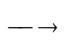 CO₂(g) + 2 H₂O() is spontaneous at room temperature.
The reverse reaction is nonspontaneous at room temperature: CO₂(g) + 2 H₂O() CH₄(g) + 2 O₂(g)

In general, the reverse of a spontaneous process (reaction) is nonspontaneous.

Spontaneity depends upon pressure and temperature.

- ice spontaneously melts at external temperatures greater than 0ºC (at atmospheric pressures)
- water spontaneously freezes into ice at temperatures less than 0ºC (at atmospheric pressures)

What determines whether a reaction (process) is spontaneous?
Reactions that produce heat (exothermic) tend to be spontaneous:
energy of products is lower than the energy of the reactants

However, endothermic processes can be spontaneous (i.e. melting of an ice cube). So some other factor(s) involved.

Irreversible process: processes in which reversal results in a net change in either the system or the surroundings. The figure below illustrates an irreversible process.
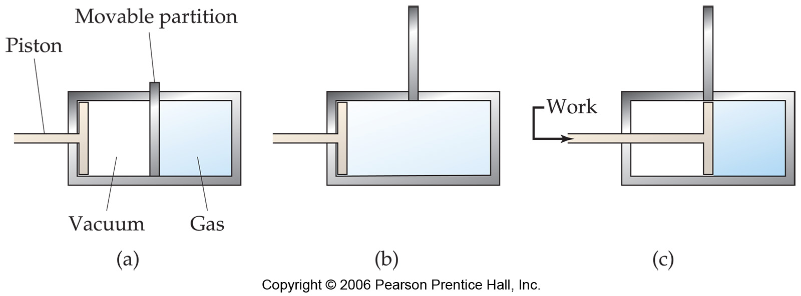
Removal of the partition from a → b results in expansion of a gas. Because the pressure in a vacuum is 0, no work occurs.
w = – PΔV Return to initial conditions requires the surroundings to perform work on the system. Thus the net change in the process is an input of work energy by surroundings.

Reversible process: process in which the process can be reversed by exact reversal of the change. A process in which no net change in system or surrounding occurs. See figure 19.4 for a description of a reversible process. Reversible processes are theoretical and require infinitesimal changes in either work or heat (and an infinite amount of time).

Any spontaneous process is irreversible. All real world processes are necessarily irreversible.

19.2 Entropy and the Second Law of Thermodynamics.

Symbol S For a closed thermodynamic system, a quantitative measure of the amount of thermal energy not available to do work.

Entropy: S is a state function, therefore ΔS = S_{f} – S_{i} independent of path.

Partial definition of entropy: measure of the disorder or randomness of a system or extent of energy distribution of motion of molecules in a system.

ΔS = for an isothermal process, ΔS = the heat transfer for a reversible process divided by the temperature at which this occurs. Isothermal means “without a change in temperature” or ΔT = 0. T must be in Kelvin.

Example: What is the change in entropy (ΔS) when 25 g of liquid water at 0ºC is frozen into ice at 0ºC?

Solution: ΔS =

The heat transfer for converting 1 mol of ice into 1 mol of water is the molar enthalpy of fusion for water, ΔH_{fus}. Because the freezing in this example occurs at 0ºC, there is no temperature change, and the process is isothermal. ΔH_{fus} = 6.01 kJ/mol for water at 0ºC.

In this problem, the water is frozen (which is the reverse of melting or fusion), so ΔH = –6.01 kJ/mol. So to freeze water, heat is removed.

So, now to calculate the heat transfer needed to freeze 25 g of water:

25 g H₂O = –8.3 kJ

ΔS = = = = –0.031 kJ or –31 J

The entropy change is negative because liquid water is LESS disordered and LESS random than solid ice. Thus in transitioning from water to ice, randomness is decreased and entropy is decreased.

The change in entropy associated with the isothermal melting of 25 g of ice at 0ºC would be +31 J.

Criteria for spontaneity – 2nd Law of Thermodynamics

The Second Law of Thermodynamics: For any spontaneous process, the entropy of the universe increases.

or, for a spontaneous process: ΔS_{universe} = ΔS_{system} + ΔS_{surroundings} > 0

This is an important and profound statement. This gives direction to processes. Knowing the impact on the entropy of the universe tells us what will and will not occur spontaneously.

19.3 The Molecular Interpretation of Entropy

Consider a molecule. It will have 3 types of motion associated with it:

Translational – moving through space
Vibrational – atoms in bonds vibrate
Rotational – spinning

Consider a lot of molecules. Entropy is a measure of disorder. The more vibrational, rotational, and translational energies populated by a collection of molecules means greater entropy.

Consider a group of molecules, without translational, vibrational, or rotational energies and highly ordered. This would represent the lowest possible amount of entropy.

3rd Law of Thermodynamics:
The entropy of a perfect and pure crystalline substance at 0 Kelvin is zero.

If we take a pure and perfect crystal at 0 K and begin to add heat to it, the temperature of the crystal begins to rise. The addition of heat adds energy to the crystal. Molecules begin to move in their sites, atoms within molecules begin to vibrate. As the temperature increases, the entropy of the crystal increases, as shown in the figure to the right.

Adding sufficient heat to the crystal, the individual molecules making up the crystal gain enough energy to move from their lattice positions. This is melting; and as can be seen in the figure, as the substance transitions from solid to liquid, an abrupt increase in entropy occurs, without an increase in temperature. Adding additional heat increases the translational, vibrational, and rotational energies of the molecules.

When sufficient heat has been transferred to the liquid, another abrupt increase in entropy is observed. This occurs when the molecules have sufficient energy to overcome the intermolecular forces; this is when the liquid starts to boil. At greater temperatures, the substance exists as a gas and further increases in temperature further increase the translational, vibrational, and rotational energies of the molecules.
Qualitative Predictions About ΔS

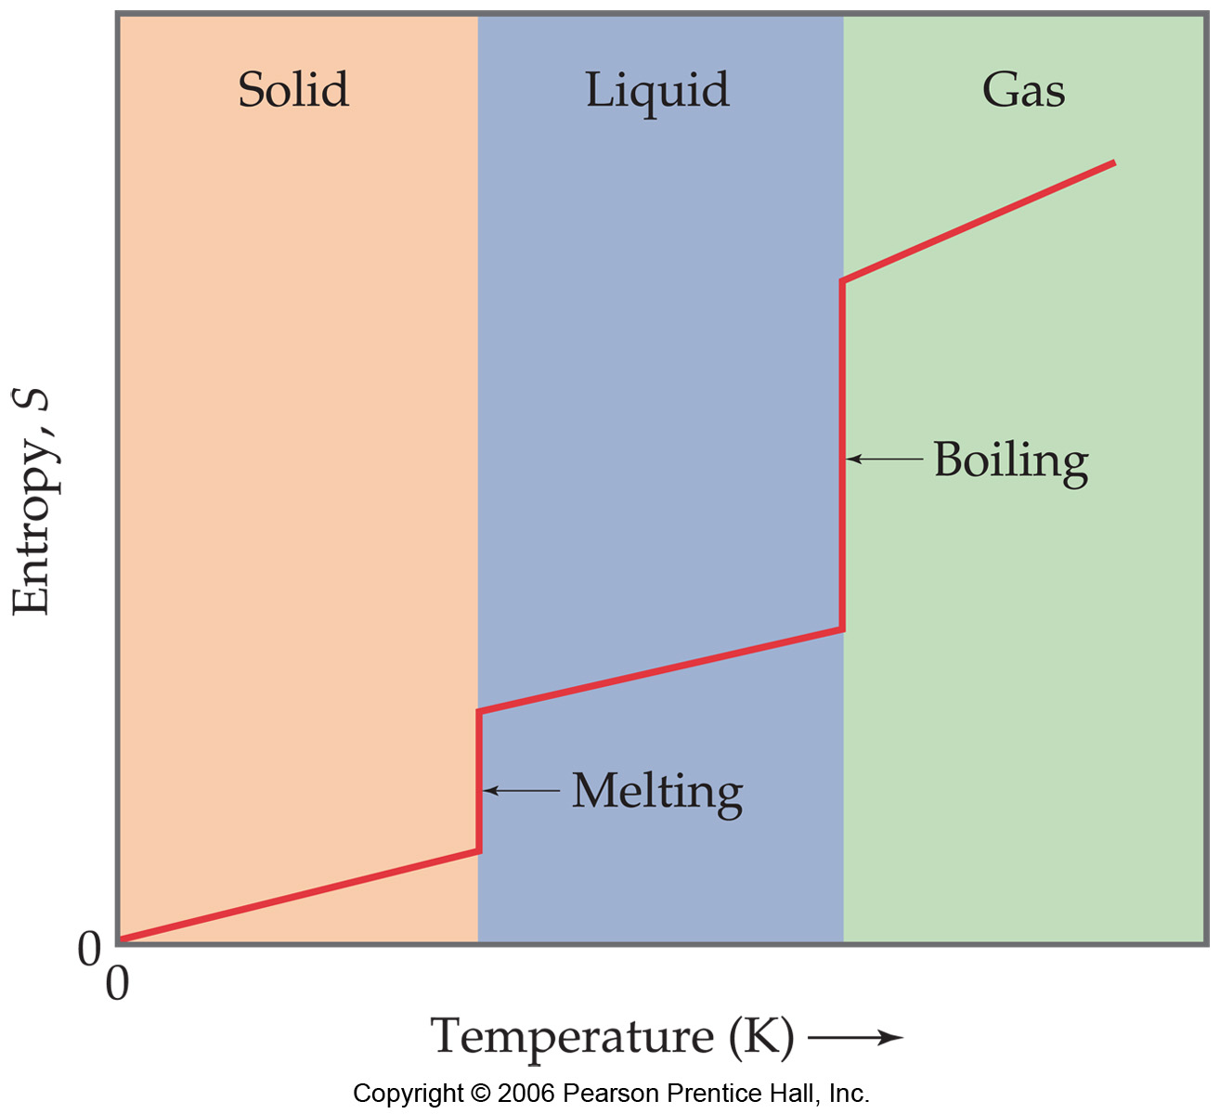
The following increase the variety of different energy states for a given system and therefore are accompanied by an increase in entropy:
1. Increased temperature
2. Increased volume
3. Increased number of moving particles.

In chemical reactions, entropy increases when:

1. gases are formed from solids or liquids
2. Liquids or solutions are formed from solids.
3. The number of gas molecules increases
during a chemical reaction.

Example: For the following reactions, determine whether entropy increases (ΔS is positive) or decreases (ΔS is negative).
a) NaCl(s) 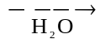 Na⁺(aq) + Cl–(aq)
b) 4 K(s) + O₂(g) 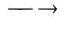 2 K₂O(s)
c) 2 H₂(g) + O₂(g) 2 H₂O(g)
Solutions:
a) This reaction starts with a pure solid and a pure liquid and ends with a mixture (solution) of solvent (water) and dissolved ions. Disorder has increased and therefore ΔS is positive, entropy increases.
b) In this reaction, a gas is consumed and a solid results. The entropy has decreased and ΔS is negative.
c) In this reaction the number of free particles (moles of gas) is reduced from 3 to 2; the entropy has decreased and ΔS is negative.
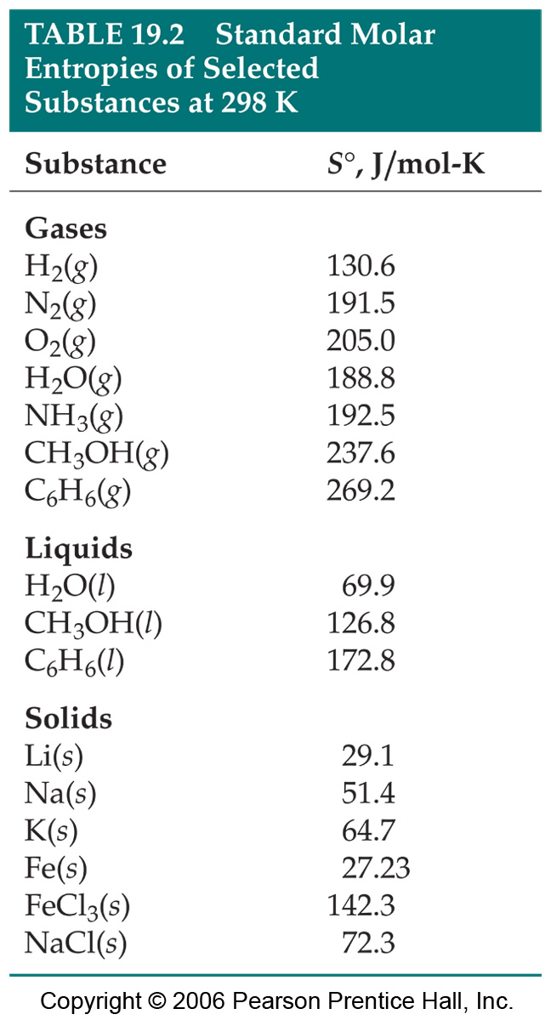
19.4 Entropy Changes in Chemical Reactions

Entropy is 0 (zero) for all pure substances at 0 Kelvin.

Standard Molar Enthalpy, Sº: the enthalpy of 1 mol of a substance at standard state. Standard state is indicated by “º.” A table of selected standard molar entropies is shown to the right.

Standard State: pure substance at P = 1 atm and T = 298 K.

Some generalizations about Sº:
- Sº is NOT 0 for pure elements.
- Sº for gases are greater than Sº for liquids and solids.
- Sº increases with molar mass.
- Sº generally increase with increasing numbers of atoms in formula.

The entropy change in a chemical reaction, ΔS_{rxn}, is determined by subtracting the entropies of the reactants (initial state) from the entropies of the reactants (initial state):

Reactants Products
ΔS_{rxn} = S_{final} - S_{initial}

ΔS_{rxn} = S(products) – S(reactants)

And for reactants and products in their standard states:

ΔSº_{rxn} = Σ nSº(products) – Σ mSº(reactants)

where m, n are the moles of products/reactants in balanced rxn eqn.
Example: Calculate the change in entropy (ΔSº) for the following reaction:

a) 2 H₂(g) + O₂(g) 2 H₂O(g)
b) 2 H₂(g) + O₂(g) 2 H₂O()

Solution: Using the standard molar entropies, Sº, from Appendix C in the text.

a) For the reaction: 2 H₂(g) + O₂(g) 2 H₂O(g)
ΔSº = Σ nSº(products) – Σ mSº(reactants) = 2 Sº(H₂O(g)) – { 2 Sº(H₂(g)) + Sº(O₂(g)) }

ΔSº = 2 (188.83 ) – { 2 (130.58 ) + 205.0 } = – 88.5

b) For the reaction: 2 H₂(g) + O₂(g) 2 H₂O()
ΔSº = Σ nSº(products) – Σ mSº(reactants) = 2 Sº(H₂O()) – { 2 Sº(H₂(g)) + Sº(O₂(g)) }

ΔSº = 2 (69.91 ) – { 2 (130.58 ) + 205.0 } = – 326.3

Note that the change in entropy, ΔS, is more negative for the production of liquid water than the production of gaseous water. This makes sense – the reactants are identical; liquid water is more ordered than is gaseous water (fewer energy states available) and therefore has a lower entropy than does gaseous water.

Entropy Changes in the Surroundings

ΔS_{surroundings} is determined by the heat transferred by the reaction:

ΔS_{surroundings} = –

And for a reaction performed at constant pressure (i.e. open to the atmosphere), q_{sys} = q_{rxn,p} = ΔH

Example: Calculate the change in entropy (ΔSº) of the surroundings for the following reactions performed open to the atmosphere and at 25ºC:

a) 2 H₂(g) + O₂(g) 2 H₂O(g)
b) 2 H₂(g) + O₂(g) 2 H₂O()
Solution:
ΔSº_{surroundings} = – = – = –

Using the enthalpies of formation, ΔH_{f}º, from Appendix C in the text, to calculate ΔHº_{rxn} and then ΔSº.

a) For the reaction: 2 H₂(g) + O₂(g) 2 H₂O(g)
ΔHº = Σ nΔHº(products) – Σ mΔHº(reactants) = 2 ΔHº(H₂O(g)) – { 2 ΔHº(H₂(g)) + ΔHº(O₂(g)) }

ΔHº = 2 (–241.82 ) – { 2 (0 ) + 0 } = – 483.64 kJ

ΔSº_{surroundings} = – = – = 1.62 = 1.62 × 10³

ΔSº_{universe} = ΔSº_{system} + ΔSº_{surroundings} = 1.62 × 10³ + = 1.53 × 10³
Note that for this reaction, ΔS_{universe} > 0, and this reaction is spontaneous

b) For the reaction: 2 H₂(g) + O₂(g) 2 H₂O()
ΔHº = Σ nΔHº(products) – Σ mΔHº(reactants) = 2 ΔHº(H₂O()) – { 2 ΔHº(H₂(g)) + ΔHº(O₂(g)) }

ΔHº = 2 (–285.83 ) – { 2 (0 ) + 0 } = – 571.66 kJ

ΔSº_{surroundings} = – = – = 2.02 = 2.02 × 10³

ΔSº_{universe} = ΔSº_{system} + ΔSº_{surroundings} = 2.02 × 10³ + = 1.69 × 10³

Note that for this reaction, ΔS_{universe} > 0, and this reaction is spontaneous AND this reaction has a greater increase in the entropy of the universe.

The figure to the right shows processes that lead to an increase in entropy (ΔS > 0).
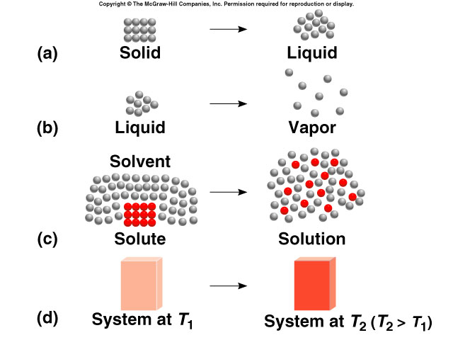

19.5 Gibbs Free Energy

Gibbs Free Energy: G is symbol

Definition: G = H – TS

Where T = absolute temperature (Kelvin)

At constant temperature:

ΔG = ΔH – TΔS

Significance:

ΔS_{universe} = ΔS_{system} + ΔS_{surroundings} => ΔS_{universe} = ΔS_{system} +

ΔS_{universe} = ΔS_{system} – => ΤΔS_{universe} = TΔS_{system} – ΔH_{sys}

–ΤΔS_{universe} = ΔH_{sys} – TΔS_{system}

Thus ΔG = –ΤΔS_{universe} and: ΔG = ΔH – TΔS = –ΤΔS_{universe}

- This is incredibly important. For a processes at constant temperature, ΔG is directly related to ΔS_{universe}. Because of the 2nd Law of Thermodynamics (all spontaneous processes: ΔS_{universe} > 0), the sign of DG (change in free energy) determines spontaneity.

For constant Temperature processes:

spontaneous process | ΔS_{universe} > 0 | ΔG < 0
nonspontaneous process | ΔS_{universe} > 0 | ΔG < 0
process at equilibrium | ΔS_{universe} = 0 | ΔG = 0

So, we now have criteria for spontaneity based solely upon system parameters:
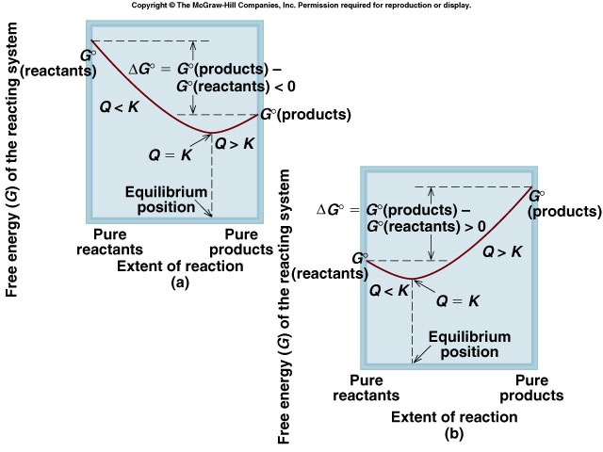
- ΔG > 0 (ΔH – TΔS > 0): nonspontaneous
- ΔG = 0 (ΔH – TΔS = 0): equilibrium
- ΔG < 0 (ΔH – TΔS < 0): spontaneous

Recall reaction quotient, Q

When Q < K, reaction occurs in forward direction towards K (spontaneous and therefore ΔG < 0)
When Q = K, reaction at equilibrium
When Q > K, reaction occurs in reverse direction towards K (nonspontaneous and therefore ΔG > 0)
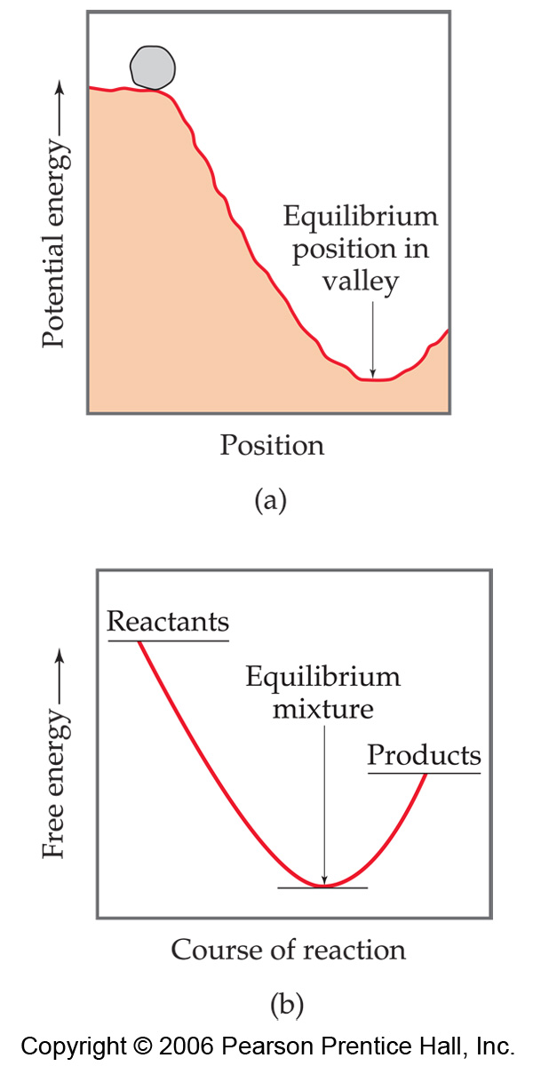
- ΔG is a state function (independent of path)

Standard Free Energy of Formation, ΔG, is the free energy change associated with the formation reaction:

elements in standard state 1 mol compound in standard state
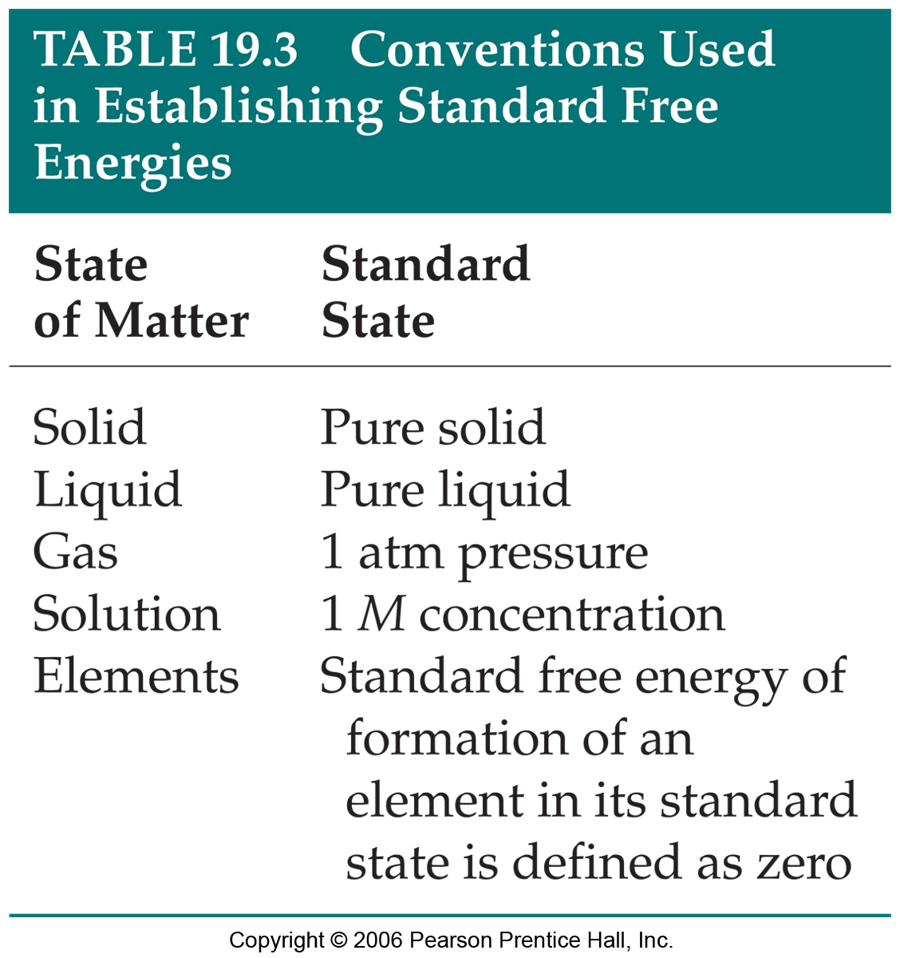

Standard state: pure solid or liquid, 1 atm pressure, 1 M solution; generally at T = 25ºC (298 K).

For example:
H₂(g) + O₂(g) H₂O(g) ΔG = – 228.57 J/mol

This means that the change in free energy at 25ºC (298 K) for the production of 1 mol of H₂O in the gas phase from elements in their standard state is – 228.57 J/mol.

and: H₂(g) + O₂(g) H₂O() ΔG = – 120.4 J/mol

This means that the change in free energy at 25ºC (298 K) for the production of 1 mol of H₂O in the liquid phase from elements in their standard state is – 120.4 J/mol.

And, this is a very powerful concept. Because ΔG is a state function, ΔG can be used to calculate the standard free energy change, ΔG, of a reaction:

ΔG = Σ n ΔG (products) – Σ m ΔG(reactants)

Example: Calculate the standard free energy change in the following reaction at 298 K:

2 C₂H₂(g) + 5 O₂(g) 4 CO₂(g) + 2 H₂O()

ΔG = Σ n ΔG (products) – Σ m ΔG(reactants)

ΔG = 4 ΔG (CO₂(g)) + 2 ΔG (H₂O()) – {2 ΔG (C₂H₂(g)) + 5 ΔG (O₂(g))}

ΔG = 4 (–394.4 kJ) + 2 (–237.13 kJ) – {2 (209.2 kJ) + 5 (0 kJ)}

ΔG = –1.578 × 10³ kJ – 474.26 kJ – 418.4 kJ = –2.4707 × 10³ kJ

Thus, having a mixture of 2 mol of C₂H₂, 5 mol O₂, 4 mol CO₂, and 2 mol H₂O would spontaneously react in the forward direction. (How fast this occurs is dependent upon the kinetics and the free energy change tells us nothing about the rate of the reaction, only the direction.)

The reverse reaction: 4 CO₂(g) + 2 H₂O() 2 C₂H₂(g) + 5 O₂(g) is nonspontaneous, meaning that the reverse reaction is spontaneous.

Example: Compare ΔGº for the reaction with ΔHº of the reaction from the previous example:
2 C₂H₂(g) + 5 O₂(g) 4 CO₂(g) + 2 H₂O()

ΔH = Σ n ΔH (products) – Σ m ΔH(reactants)

ΔH = 4 ΔH (CO₂(H)) + 2 ΔH (H₂O()) – {2 ΔH (C₂H₂(H)) + 5 ΔH (O₂(H))}
ΔH = 4 (–393.5 kJ) + 2 (–285.83 kJ) – {2 (226.77 kJ) + 5 (0 kJ)}
ΔH = –1.574 × 10³ kJ – 571.66 kJ – 453.54 kJ = –2.5992 × 10³ kJ

and from the previous example, ΔG = –2.4707 × 10³ kJ.

Note that ΔH is more negative than ΔGº.
This makes sense: ΔG = ΔH – TΔS

For this reaction, 5 moles of gas is transformed to 4 moles of gas, thus ΔS_{rxn} < 0 (entropy of the reaction or system is reduced). Thus –TΔS is positive. Therefore, ΔH must be more negative than ΔG.
19.6 Free Energy and Temperature

ΔG = ΔH – TΔS
Enthalpy
Term
Entropy
Term

Free energy change (at constant T), is determined by two “terms” or factors:
- enthalpy term
- entropy term

As the table shows, at low temperatures (T is small), the enthalpy term dominates; at high temperatures, the entropy term dominates.

Summary:
exothermic processes (ΔH < 0) contribute to spontaneity (ΔG < 0)
positive ΔS_{rxn} or ΔS_{system} contribute to spontaneity
for an endothermic process (ΔH > 0) to be spontaneous, ΔS_{rxn} or ΔS_{system} must be > 0 (positive).

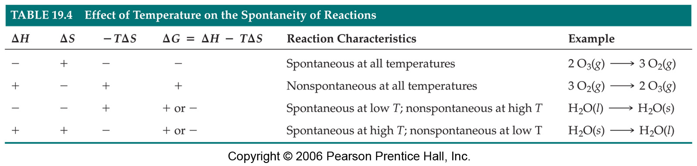

Consider the vaporization of water: H₂O() H₂O(g)

ΔHº_{vap} = +44
ΔSº_{vap} = +0.12

Assuming that ΔH and ΔS and don’t change much at different temperatures:

ΔGº = ΔHº – TΔSº => ΔG = +44 – T × +0.119

When T × +0.12 = +44 ; i.e. when ΔHº = TΔSº, ΔGº = 0

and T = 370 K or about 100ºC

Thus at T > 100ºC or 370 K; water spontaneously converts to steam (vaporizes)
at T < 100ºC or 370 K; water vapor spontaneously converts to water (condenses)
and at T = 100ºC; water and vapor coexist (equilibrium)

Note: Using this method, the temperature at which liquid and vapor are in equilibrium (the boiling point) is determined to be 369.8 K or 97.7ºC. The reason that this is not exactly 100ºC is because ΔH and ΔS do in fact change with temperature. But we can see that the change is not huge. ΔH_{vap} at 100ºC is 40.67 kJ compared to 44.02 at 25ºC and ΔS_{vap} = 0.109 kJ . Knowing the exact values of ΔH and ΔS at 100ºC yields the correct boiling point.

Importance: Using ΔHº and ΔSº, one can determine approximate temperature regimes where reactions are spontaneous and nonspontaneous.

19.7 Free Energy and the Equilibrium
spontaneous process | ΔS_{universe} > 0 | ΔG < 0 | Q < K
nonspontaneous process | ΔS_{universe} < 0 | ΔG < 0 | Q > K
process at equilibrium | ΔS_{universe} = 0 | ΔG = 0 | Q = K
In section 6, we related the equilibrium constant, K¸ and the reaction quotient, Q, to spontaneity.

Free energy change at nonstandard conditions can be calculated using:

ΔG = ΔGº + RT lnQ
where R = the ideal-gas constant, 8.314 and Q is the reaction quotient.

If all reactants and products are at standard state, then Q = 1 and lnQ = 0, and: ΔG = ΔGº

Example: Estimate the normal boiling point of benzene C₆H₆.

Solution: This problem is very similar to the example worked in section 6 of the lecture notes (boiling point of water).


i) at the boiling point, liquid and gas phase are in equilibrium: : C₆H₆() C₆H₆(g)

ii) ΔG = ΔGº + RT lnQ and Q = P_{C6H6} and normal boiling point means P = 1 atm; Q = 1;
therefore: ΔG = ΔGº

And because at the boiling point, the liquid and vapor are at equilibrium, ΔG = ΔGº = 0

iii) From section 6: ΔGº = ΔHº - TΔSº

With ΔGº = 0:

ΔHº - TΔSº = 0 and T =

ΔHº = ΔH(C₆H₆(g)) – ΔH(C₆H₆()) = 82.9 kJ – 49.0 kJ = 33.9 kJ
ΔHº = ΔSº(C₆H₆(g)) – ΔSº(C₆H₆()) = 269.2 – 172.8 = 96.4

T = = = 352 K or 78.5ºC

Literature value for boiling point benzene: 80.1ºC; again this differs from the calculated value because we assumed that ΔH and ΔS are independent of the temperature.

Example: Calculate ΔG for the following reaction at 298 K

NH₃(aq) + H₂O() NH₄⁺(aq) + OH–(aq)

with [NH₃] = 3.0 M , [NH₄⁺] = 1.0 × 10^{–3} M, and [OH–] = 1.0 × 10^{–3} M.

Solution:

ΔG = ΔGº + RT lnQ

ΔG = ΔG (NH₄⁺(aq)) + ΔG (OH–(aq)) – { ΔG (NH₃(aq)) + ΔG (H₂O()) }

ΔG = –79.3 kJ + (–157.3 kJ) – { (–26.5 kJ) + (–237.13 kJ) }

ΔG = –79.3 kJ – 157.3 kJ + 26.5 kJ + 237.13 kJ = +27.03 kJ

27.03 kJ = 2.703 × 10⁴ J

Note: the positive ΔGº means that starting with 1 M NH₄⁺, OH–, and NH₃ the rxn proceeds towards reactants (spontaneous in the reverse direction).

ΔG = 27.03 kJ + RT lnQ and Q =

RT lnQ = 8.3144 × 298 K × ln

RT lnQ = 2.48 × 10³ × ln

RT lnQ = 2.48 × 10³ J × ln 3.3 × 10^{–7}

RT lnQ = 2.48 × 10³ J × (– 14.91)

RT lnQ = – 3.79 × 10⁴ J = –37.9 kJ

ΔG = 27.03 kJ + RT lnQ = 27.03 kJ – 37.9 kJ = – 10.9 kJ

Thus, under the stated conditions, the reaction is spontaneous in the forward direction.
When a reaction is at equilibrium, Q = K and ΔG = 0

So at equilibrium: ΔG = ΔGº + RT lnK = 0

and from ΔGº + RT lnK = 0 , we have: ΔGº = – RT lnK

and – = lnK and K=

Example: Calculate K for the following reaction at 298 K

NH₃(aq) + H₂O() NH₄⁺(aq) + OH–(aq)

Solution:

K =
From the previous example, ΔG = +27.03 kJ = 2.703 × 10⁴ J

K =

– = – = – 10.91

K = = = 1.8 × 10^{–5}

This agrees with the base dissociation constant K_{b} for NH₃ from the appendix

