DIMENSION of NUCLEUS:
It was in the large angle scattering of alpha particles from aluminum that Rutherford was first able to show a deviation from Coulomb scattering. This point of departure, discovered in 1919, was close enough to 180 degrees to make the backscatter calculation for aluminum a reasonable way to estimate nuclear size.
The closest approach to the aluminum nucleus can be calculated from conservation of energy by simply setting the initial kinetic energy of the alpha particle equal to the electrostatic potential energy it has at the instant it stops close to the aluminum nucleus.
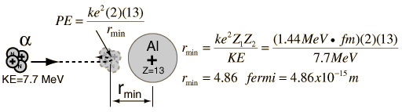
A more current estimate of the size of the aluminum nucleus can be obtained by subsituting the mass number of aluminum (Z=27) into the nuclear radius relationship. That gives a nuclear radius of 3.6 fm for aluminum. Considering that within the decade of Rutherford's experiments, the positive charge in an atom was thought to be 30,000 times larger, his results become all the more impressive.

http://hyperphysics.phy-astr.gsu.edu/hbase/nuclear/nucuni.html#c4

