Ernest Rutherford(1909-1911) and his student - Hans Geiger conducted experiments to search the problem of alpha particles scattering by the thin gold-leaf. Rutheford knew that the particles contain the 2e charge.

The experiment caused the creation of the new model of atom - the "planetary" model.
Rutherford examined the angle of scattering fast alpha particles from the source ²¹⁴Po after penetrating thin gold leaf. The gold leaf was about 5*10⁻⁷ meter thick. The scientist knew that the scattering angle could say much about the structure of atoms of the gold-leaf.

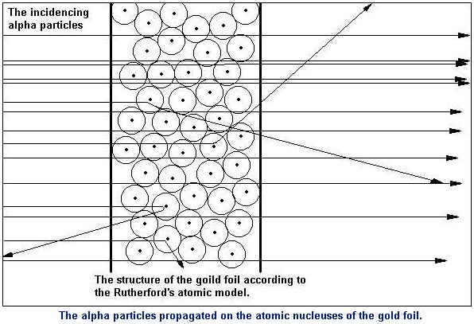

Rutherford made a theoretical analysis of angles of scattering in accordance with Thomson's theory of atom and in accordance with his own theory. He assumed that atom consisted of positive charged nucleus and negative charged electrons circling around the nucleus. Then his theoretic calculations he compared with the experiment result. Alpha particles going through atom created in accordance with the "plum cake" model wouldn't be strong alterred because the electric field in that atom wouldn't be strong. In the model created by Rutherford the field is much stronger near to the nucleus, so some of alpha particles are any alpha particle will hit the nucleus is small but possible.

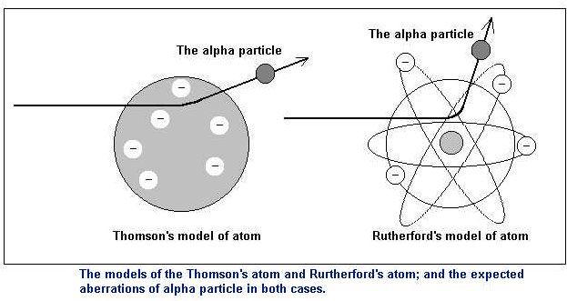

http://dbhs.wvusd.k12.ca.us/webdocs/Chem-History/Rutherford-atom-abstract.html

