Michael Faraday (1850’s) performed a series of experiments that was not explainable with the atom as the fundamental particle.
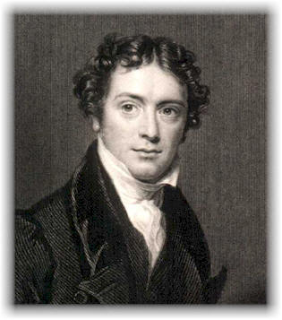
- Ran electrical current through molten solids and solutions (electrolysis)
- Metals weren’t changed
- Solution:
Materials deposited on electrodes
Gases were produced
Electrodes eaten away
Conclusion: chemical changes take place during electrolysis

Faraday’s Laws:
1. The amount of chemical change (grams of Ag produces, etc.) occurring at an electrode is directly proportional to the amount of electricity passed through the electrode.
2. If the same amount of electricity is passed through different solutions, the ratio of the weights of the elements produced or consumed at the various electrodes is either the same as the ratio of their atomic weights or their atomic weights multiplied or divided by small whole numbers.

BUT He didn’t come up with interpretations.

G. Johnstone Stoney picked back up with Faraday’s results.

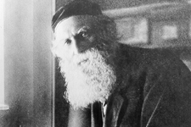
Stoney’s theory:
- Electricity is particulate. (made up of minute particles)
- The atom is electrical in nature. (interacts with electricity)
- Whatever is electrical in the atom is also particulate.
- Coined the phrase “electron” for this particle in 1891
- Shows that the atom is not the fundamental particle (from him)

Electron’s existence is only theoretical

http://www-gap.dcs.st-and.ac.uk/~history/Mathematicians/Faraday.html
http://dbhs.wvusd.k12.ca.us/webdocs/Chem-History/Stoney-1894.html

