MULLIKAN OIL DROP EXPERIMENT (1909)

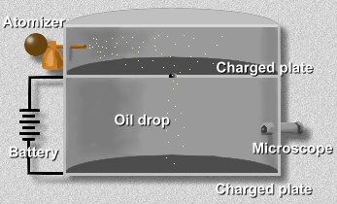
An atomizer sprayed a fine mist of oil droplets into chamber.
Some of these tiny droplets fell through a hole in upper floor.

Millikan first let them fall until they reached terminal velocity.

Using the microscope, he measured their terminal velocity, and calculated the mass of each oil drop.
Next, Millikan applied a charge to the falling drops by illuminating the bottom chamber with x-rays. This caused the air to become ionized, and electrons to attach themselves to the oil drops.
By attaching a battery to the plates above and below this bottom chamber, he was able to apply an electric voltage.

The electric field would act on the charged oil drops;
If the voltage was just right, the electromagnetic force would just balance the force of gravity on a drop, and the drop would hang suspended in mid-air.

When a drop is suspended, its weight m · g is exactly equal to the electric force applied q · E
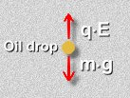
The values of E, the applied electric field, m the mass of a drop, and g, tha acceleration due to gravity, are all known values. So you can solve for q, the charge on the drop:
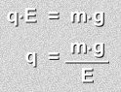
Millikan determined the charge on a drop. Then he redid the experiment numerous times, each time varying the strength of the x-rays ionizing the air, so that differing numbers of electrons would jump onto the oil molecules each time. He obtained various values for q.
The charge q on a drop was always a multiple of -1.6 x 10 ⁻¹⁹ C, the charge on a single electron.
This number was the one Millikan was looking for, and it also showed that the value was quantized; the smallest unit of charge was this amount, and it was the charge on a single electron.

Electron Mass = 1.60 x 10⁻¹⁹ C = 9.10 x 10⁻²⁸ g 1.76 x 10⁸ C/g

