The Mass Spectrometer(MS)
Mass spectrometers are pieces of equipment designed to measure atomic and molecular masses accurately.
- The sample is charged as soon as it enters the spectrometer.
- The charged sample is accelerated using an applied voltage.
- The ions are then passed into an evacuated tube and through a magnetic field.
- The magnetic field causes the ions to be deflected by different amounts depending on their mass.
- The ions are then detected.
- A graph of signal intensity vs. mass of the ion is called a mass spectrum.
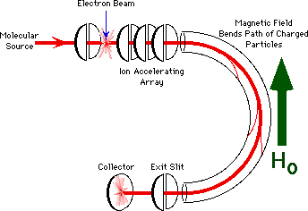

http://ull.chemistry.uakron.edu/gcms/MS_detector/index.html

