Ball-and-stick models

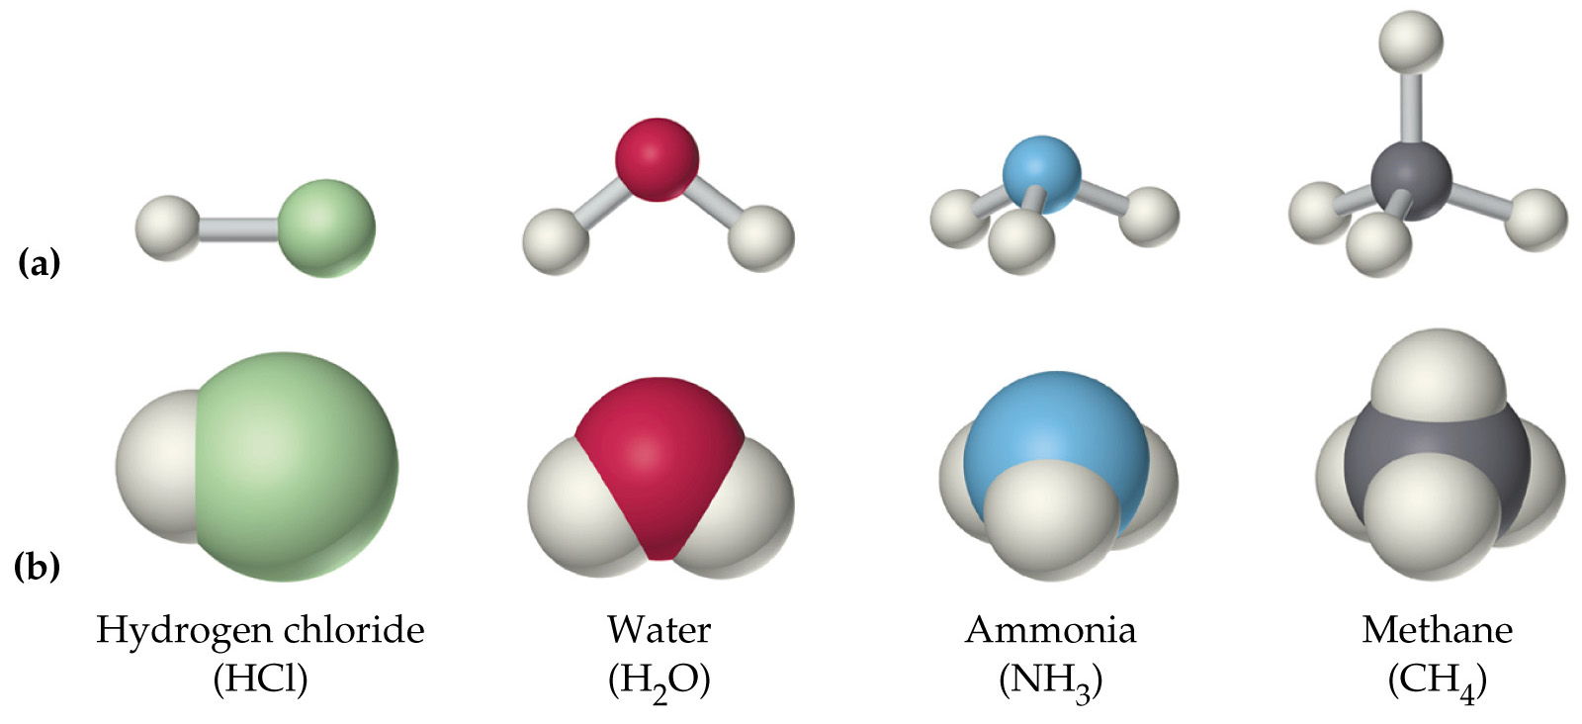
Space-filling models

