Naming Inorganic Compounds
With over 10 million known chemicals, and potentially dangerous results if chemicals are combined in an incorrect manner, imagine the problem if you are in the lab and say "mix 10 grams of that stuff in with this stuff". We need to be very clear on identification of chemicals.
Two early classifications of chemical compounds:
- Organic compounds. These contain the element Carbon (C). "Life on earth is carbon based"
- Inorganic compounds. All other compounds
Organic compounds were associated with living organisms, however, a large number have been synthesized which do not occur in nature, so this distinction is no longer valid.
Ionic compounds: (an association of a cation and an anion)
The positive ion (cation) is always named first and listed first in writing the formula for the compound.
The vast majority of monatomic (composed of a single atom) cations are formed from metallic elements:
- Na⁺ Sodium ion
- Zn²⁺ Zinc ion
- Al³⁺ Aluminum ion
If an element can form more than one positive ion, the positive charge of the ion is indicated by a Roman numeral in parentheses following the name of the metal:
- Fe²⁺ iron(II) ion
- Fe³⁺ iron(III) ion
- Cu⁺ copper(I) ion
- Cu²⁺ copper(II) ion
Iron and copper are examples of transition metals. They occur in the block of elements from IIIB to IIB of the periodic table.
The transition metals often form two or more different monoatomic cations.
Periodic Table

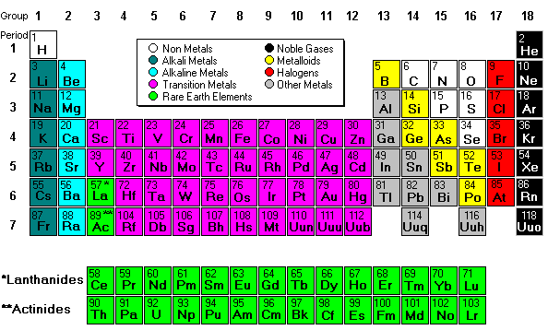
An older nomenclature for distinguishing between the different ions of a metal is to use the suffixes -ous and -ic. The suffix -ic will indicate the ion of higher ionic charge:
- Fe²⁺ ferrous ion
- Fe³⁺ ferric ion
- Cu⁺ cuprous ion
- Cu²⁺ cupric ion
Note that the different ions of the same element often have quite different chemical properties
Cations formed from non-metals end in -ium.
Examples: NH₄⁺ ammonium ion; H₃O⁺ hydronium ion.

