Ionic compounds: Anions
Monatomic anions are usually formed from non-metallic elements. They are named by dropping the ending of the element name and adding -ide:
- Cl⁻ chloride ion
- F⁻ flouride ion
- S²⁻ sulfide ion
- O²⁻ oxide ion
Some common polyatomic anions include:
- OH- hydroxide ion
- CN- cyanide ion
Many polyatomic anions contain oxygen, and are referred to as oxyanions. When an element can form two different oxyanions the name of the one that contains more oxygen ends in -ate, the one with less ends in -ite:
- NO₂⁻ nitrite ion
- NO₃⁻ nitrate ion
- SO₃²⁻ sulfite ion
- SO₄²⁻ sulfate ion
Note that unlike the -ous and -ic suffix nomenclature to distinguish the different cations of a metal, the -ite and -ate suffix is used to distinguish the relative amounts of the oxygen atoms in a (polyatomic) oxyanion
Some compounds can have multiple oxyanion forms (the oxyanions involving the halogens, for example):
- ClO⁻ ClO₂⁻ ClO₃⁻ ClO₄⁻
Note again, that the number of Oxygens relative to the Chlorine is changing, but that the ionic charge is not.
How do we name these? The -ite and -ate suffixes are still used, but we have to add an additional modification to allow us to distinguish between the four forms:
- ClO⁻ hypochlorite ion
- ClO₂⁻ chlorite ion
- ClO₃⁻ chlorate ion
- ClO₄⁻ perchlorate ion
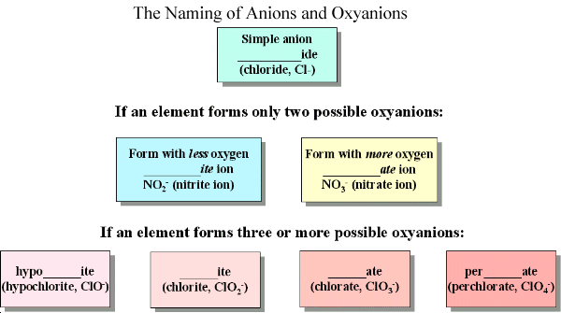
Many polyatomic anions that have high (negative) charges can add one or more hydrogen cations (H⁺) to form anions of lower effective charge. The naming of these anions reflects whether the H⁺ addition involves one or more hydrogen ions:
- HSO₄⁻ hydrogen sulfate ion
- H₂PO₄⁻ dihydrogen phosphate ion

