Some Simple Organic Compounds
Organic chemistry is the study of carbon-containing compounds.
Organic compounds are those that contain carbon and hydrogen, often in combination with other elements.
Alkanes
Compounds containing only carbon and hydrogen are called hydrocarbons. Alkanes each carbon atom is bonded to four other atoms. The names of alkanes end in -ane.

Molecular Formula Structural Formula IUPAC Name

CH₄ CH₄ Methane
C₂H₆ CH₃-CH₃ Ethane
C₃H₈ CH₃-CH₂-CH₃ Propane
C₄H₁₀ CH₃-(CH₂)₂-CH₃ Butane
C₅H₁₂ CH₃-(CH₂)₃-CH₃ Pentane
C₆H₁₄ CH₃-(CH₂)₄-CH₃ Hexane
C₇H₁₆ CH₃-(CH₂)₅-CH₃ Heptane
C₈H₁₈ CH₃-(CH₂)₆-CH₃ Octane
C₉H₂₀ CH₃-(CH₂)₇-CH₃ Nonane
C₁₀H₂₂ CH₃-(CH₂)₈-CH₃ Decane

Some Derivatives of Alkanes
When functional groups, specific groups of atoms, are used to replace hydrogen atoms on alkanes, new classes of organic compounds are obtained.

Alcohols are obtained by replacing a hydrogen atom of an alkane with an –OH group. Alcohol names derive from the name of the alkane and have an -ol ending.
Examples: methane becomes methanol; ethane becomes ethanol.

Methanol
(methyl alcohol) b.p. 65 °C , density 0.793 g/cm3, soluble in water uses: fuel, solvent, to prepare other compounds ; common name: WOOD ALCOHOL) Extremely poisonous when swallowed, attacks nervous system and optic nerve (blindness/death)
H
|
H -- C --OH
|
H
Ethanol
(ethyl alcohol) b.p. 78.5 ° density 0.789 g/cm3, soluble in water
uses: solvent, fuel, preparations, germicide, alcoholic beverages (known as GRAIN ALCOHOL because it is prepared from corn and grain plants.)
H H
| |
H --C -- C -- OH
| |
H H
3) 2-propanol
(isopropyl) b.p. 82 °C
known as common rubbing alcohol
H OH H
| | |
H - C -- C -- C -- H
| | |
H H H
4) 1-propanol
b.p. 97 °C
H H H
| | |
H -- C --C -- C -- OH
| | |
H H H

5) Ethylene glycol
antifreeze active b.p. 198 °C
H H
| |
H-C --C- H
| |
OH OH

6) Glycerine
viscous, clear liquid obtained as by product in soap making, used to make plastics, drugs, foods, cosmetics, and nitroglycerine
OH OH OH
| | |
H --C -- C -- C -- H
| | |
H H H

Carbon atoms often form compounds with long chains of carbon atoms. Properties of alkanes and derivatives change with changes in chain length.
Polyethylene, a material used to make many plastic products, is an alkane with thousands of carbons. It is an example of a polymer.

Carbon may form multiple bonds to itself or other atoms.
Examples include:

Unsaturated hydrocarbons (e.g., ethylene): contain carbon-carbon multiple bonds.
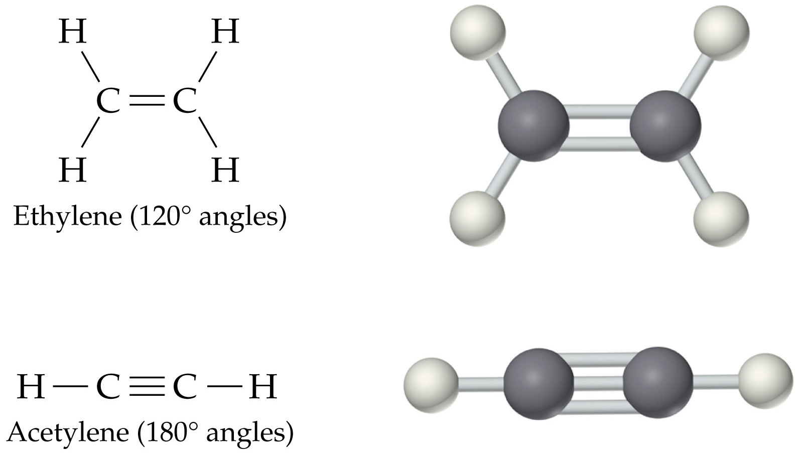

Carboxylic acids

Formula | Common Name | Source | IUPAC Name | Melting Point | Boiling Point
HCO₂H | formic acid | ants (L. formica) | methanoic acid | 8.4 ºC | 101 ºC
CH₃CO₂H | acetic acid | vinegar (L. acetum) | ethanoic acid | 16.6 ºC | 118 ºC
CH₃CH₂CO₂H | propionic acid | milk (Gk. protus prion) | propanoic acid | -20.8 ºC | 141 ºC
CH₃(CH₂)₂CO₂H | butyric acid | butter (L. butyrum) | butanoic acid | -5.5 ºC | 164 ºC
CH₃(CH₂)₃CO₂H | valeric acid | valerian root | pentanoic acid | -34.5 ºC | 186 ºC
CH₃(CH₂)₄CO₂H | caproic acid | goats (L. caper) | hexanoic acid | -4.0 ºC | 205 ºC
CH₃(CH₂)₅CO₂H | enanthic acid | vines (Gk. oenanthe) | heptanoic acid | -7.5 ºC | 223 ºC
CH₃(CH₂)₆CO₂H | caprylic acid | goats (L. caper) | octanoic acid | 16.3 ºC | 239 ºC
CH₃(CH₂)₇CO₂H | pelargonic acid | pelargonium (an herb) | nonanoic acid | 12.0 ºC | 253 ºC
CH₃(CH₂)₈CO₂H | capric acid | goats (L. caper) | decanoic acid | 31.0 ºC | 219 ºC

Ketones
Propanone (acetone) ,  