The Atomic Theory of Matter

Greek Philosophers: Can matter be subdivided into fundamental particles?
• Democritus (460–370 BC) 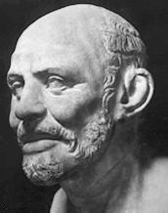
All matter can be divided into indivisible atomos.

(Plato disagreed resulting in delay in acceptance)
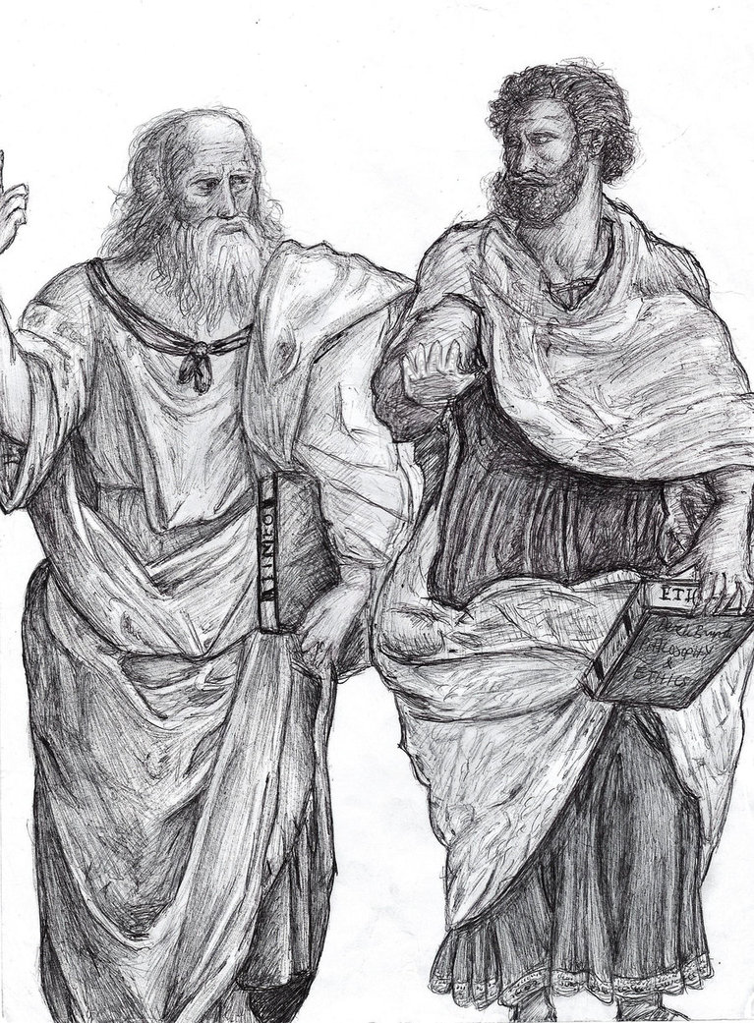
Plato & Aristotle versus Democritus

Matter is Matter composed Infinitely Divisible of small indivisible
Particles called “atoms”

John Dalton(1766-1844) 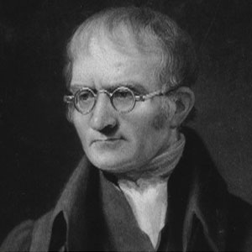

John Dalton

(1766-1844)
Proposed atomic theory with the following postulates:
- All elements are composed of atoms
- Atoms can neither be created nor destroyed (: nuclear reactions)
- All atoms of the same element are the same (: isotopes)
- Atoms of different elements are different
- Compounds are made by the union of atoms

Dalton’s theory explained:
Law of constant composition: The relative kinds and numbers of atoms are constant for a given compound.
Law of conservation of mass (matter): During a chemical reaction, the total mass before reaction is equal to the total mass after reaction.

Further it Predicted:

• Law of multiple proportions: If two elements A and B combine to form more than one compound, then the mass of B which combines with the mass of A is a ratio of small whole numbers.

However: Most people rejected it as silly and stupid

Beginning of 20th century when it was all accepted

Dalton claimed atom was a fundamental particle, but later we learn these are further made of protons, neutrons, and electrons.

http://plato.stanford.edu/entries/democritus/
http://uraltheology.net/Notes/Notes03/notesM03D09.html
http://antoine.frostburg.edu/chem/senese/101/atoms/dalton.shtml
http://particleadventure.org/particleadventure/

