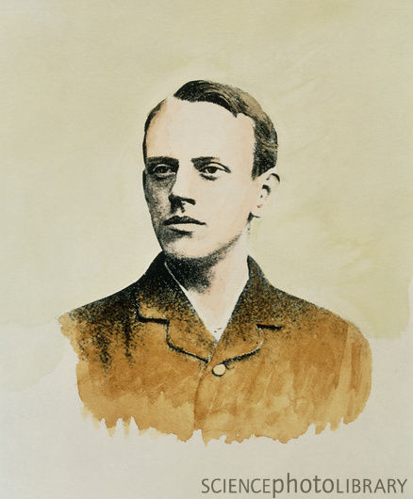
J.J. Thompson
(1856 – 1941)

Got Nobel Prize for finding the electron
Professor at age 27 & Head of Cambridge at 28, and for 35 years investigated cathode rays
Cathode Ray Tube:

- The beam had negative charge: They had “trapped” Stoney’s hypothetical electrons!
- Pass beam through electro-magnetic field, and the path bends
- Used magnet to curve path back, and measured strength of magnet because the forces are equal when straight.
- Found charge-mass ratio (e/m)
- (e/m)=-1.76 * 10⁸ coulomb/gram in every expt
- Conclusion: all elements have same particle
- All electrons are identical
- Experimented to find mass and charge
- Couldn’t find either
- There must be positive particles
- Couldn’t get positive beam
Goldstein 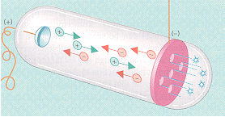

made discharge tube and detected the positives “ions” (q/m) ≈ 10⁵ coulomb/gram

BUT different values for different gases

Conclusion:
Atoms have positives and negatives
Negatives are the same,
But positives are somehow different

Thompson suggested the Plum Pudding Model(1904)


There is positive “mush” and embedded with electrons—enough to neutralize
He believed that’s what it looked like—but there’s no support for that appearance
It was consistent with experiments, but it could have been anything.
For 7 years, it was the accepted model for the atom. BUT LARGELY WRONG

http://www.ph.vu.nl/~regt/TGGNWT1989.html

