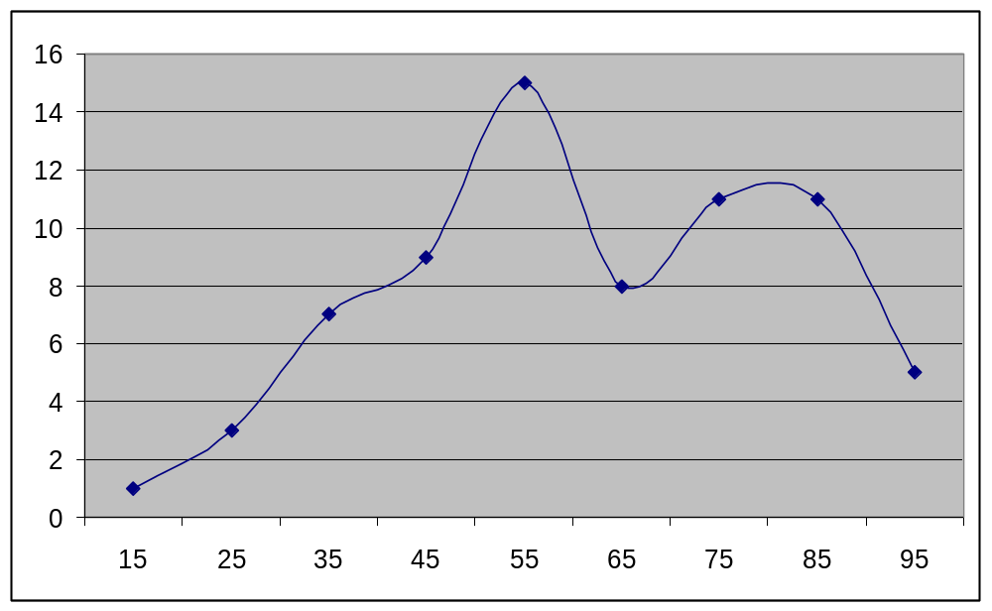
Bimodal Distribution for Chemistry 101 Examination 1

60.98 | mean
81.3 | mode
59.8 | median

