Remember, the sum of the mass percentage of each element in the compound must equal 100%.
For example, to calculate the mass percentage of each element in K₂Cr₂O₇ we need to know the following:
the atomic weight of each element (from the periodic table)
the formula weight of the compound
K₂Cr₂O₇ = 294.2 amu
the number of times each element appears in the chemical formula (from the subscripts)
The calculations are therefore as follows:

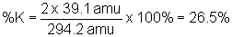
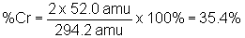
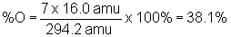

** (note : Rounding of Atomic Weights)

