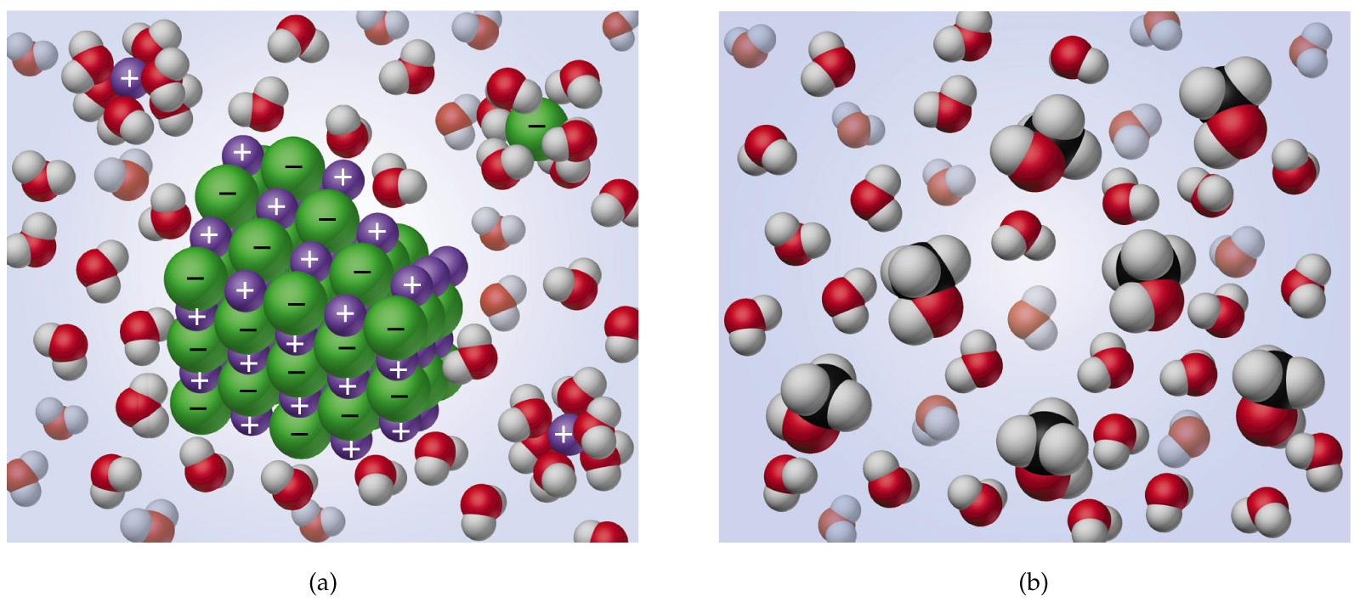
Ions dispersed in a Molecules dispersed in a
Molecular Solution(Water) Molecular Solution

