The logical starting point in the discussion of oxidation-reduction reactions is the atom, and the terms and conventions used by chemists in describing this phenomenon.

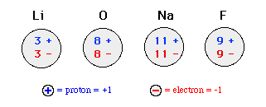
All atoms are electrically neutral even though they are comprised of charged, subatomic particles. The terms, oxidation state or oxidation number, have been developed to describe this "electrical state" of the atom.
The oxidation state or oxidation number of an atom is simply defined as the sum of the negative and positive charges in an atom

