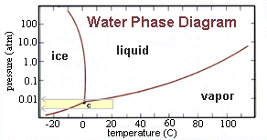

On Mars the globally-averaged surface pressure of the planet's atmosphere is only slightly less than 6.1 millibars.
The above “Phase Diagram” of water shows and interesting phenomena.

The 'triple point' (labeled "C" in the diagram) is the temperature and pressure where all three types of water can exist at once. In the diagram, note that liquid water cannot exist below 6.1 millibars. This fact is significant because the atmospheric pressure at the Martian surface hovers just below that value. Any water that might form on a warm afternoon from melting water would quickly disappear in the desiccated Martian atmosphere.

