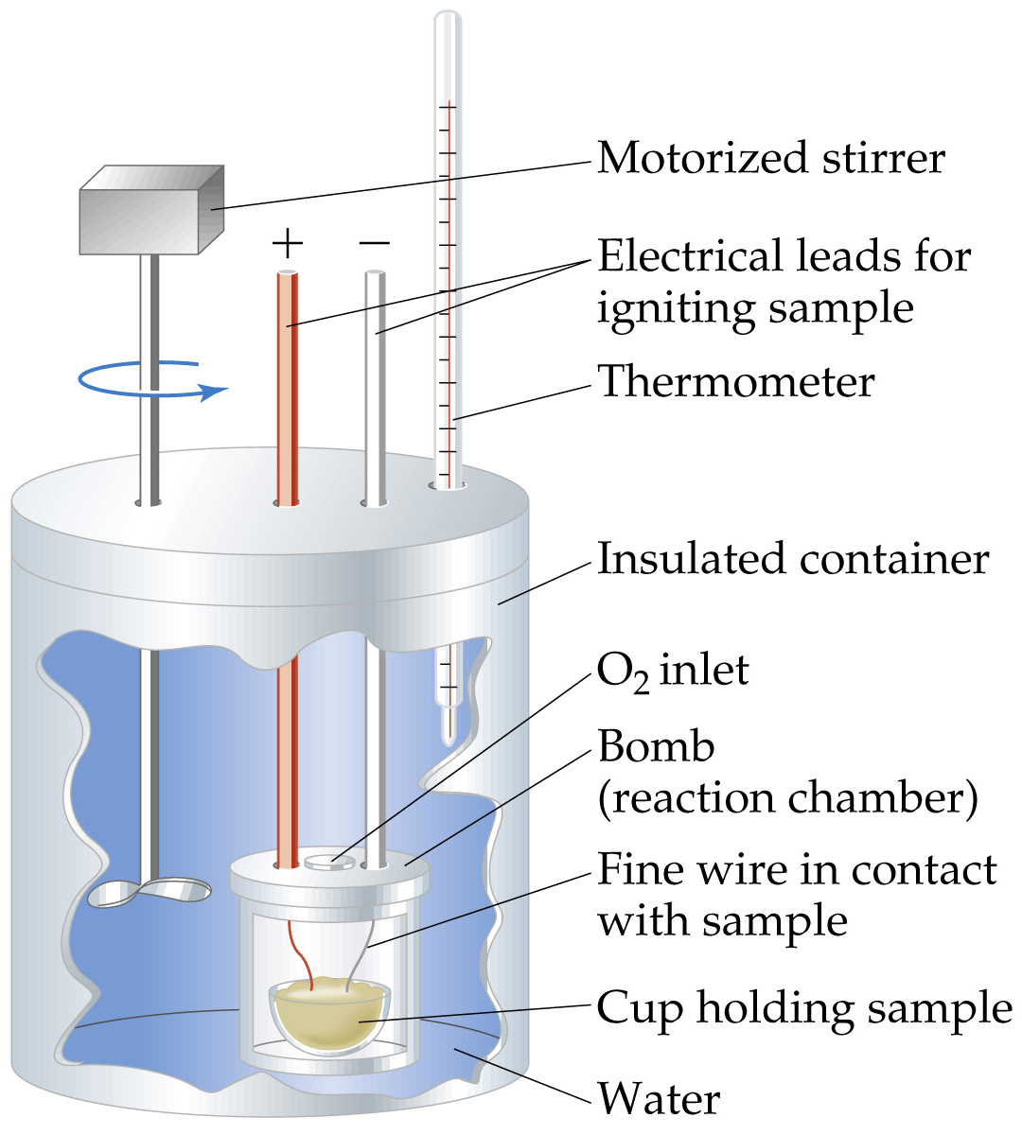
Calorimetry
Reaction carried out under constant volume.
Use a bomb calorimeter.
Usually study combustion.
Bomb Calorimetry (Constant Volume Calorimetry)

