Constant-Pressure Calorimetry
Although the calorimeters used for highly accurate work are precision instruments, a very simple "coffee-cup" calorimeter is often used in general chemistry labs to illustrate the principles of calorimetry. The heat gained by the solution, q_{soln}, is readily calculated from the mass of the solution, its specific heat, and the temperature change:
q_{soln} = mass of solution x specific heat of solution x ΔT
q_{soln} =C_{p} m ΔΤ
For dilute aqueous solutions, the specific heat of the solution will be approximately the same as that of water, 4.18 J/g-K.
Coffee-cup calorimeter, in which reactions occur at constant pressure.

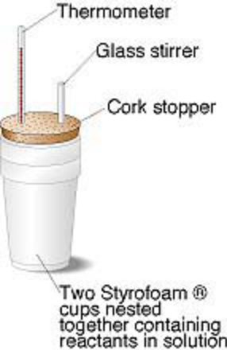
Assume there is NO LOSE of HEAT to CUP then Cp for cup is effectively equal to ZERO
The heat of the reaction, q_{rxn}, is equal in magnitude and opposite in sign from q_{soln}:
ΔH_{rxn} = ΔH_{constant p} = q _{rxm} = - q _{soln}

_{IN-CLASS EXAMPLES:}

Heat Transport (Metal + Water)

Heat of Neutralization Experiment

