Energy, Enthalpy, and P-V Work

Consider the following Piston:
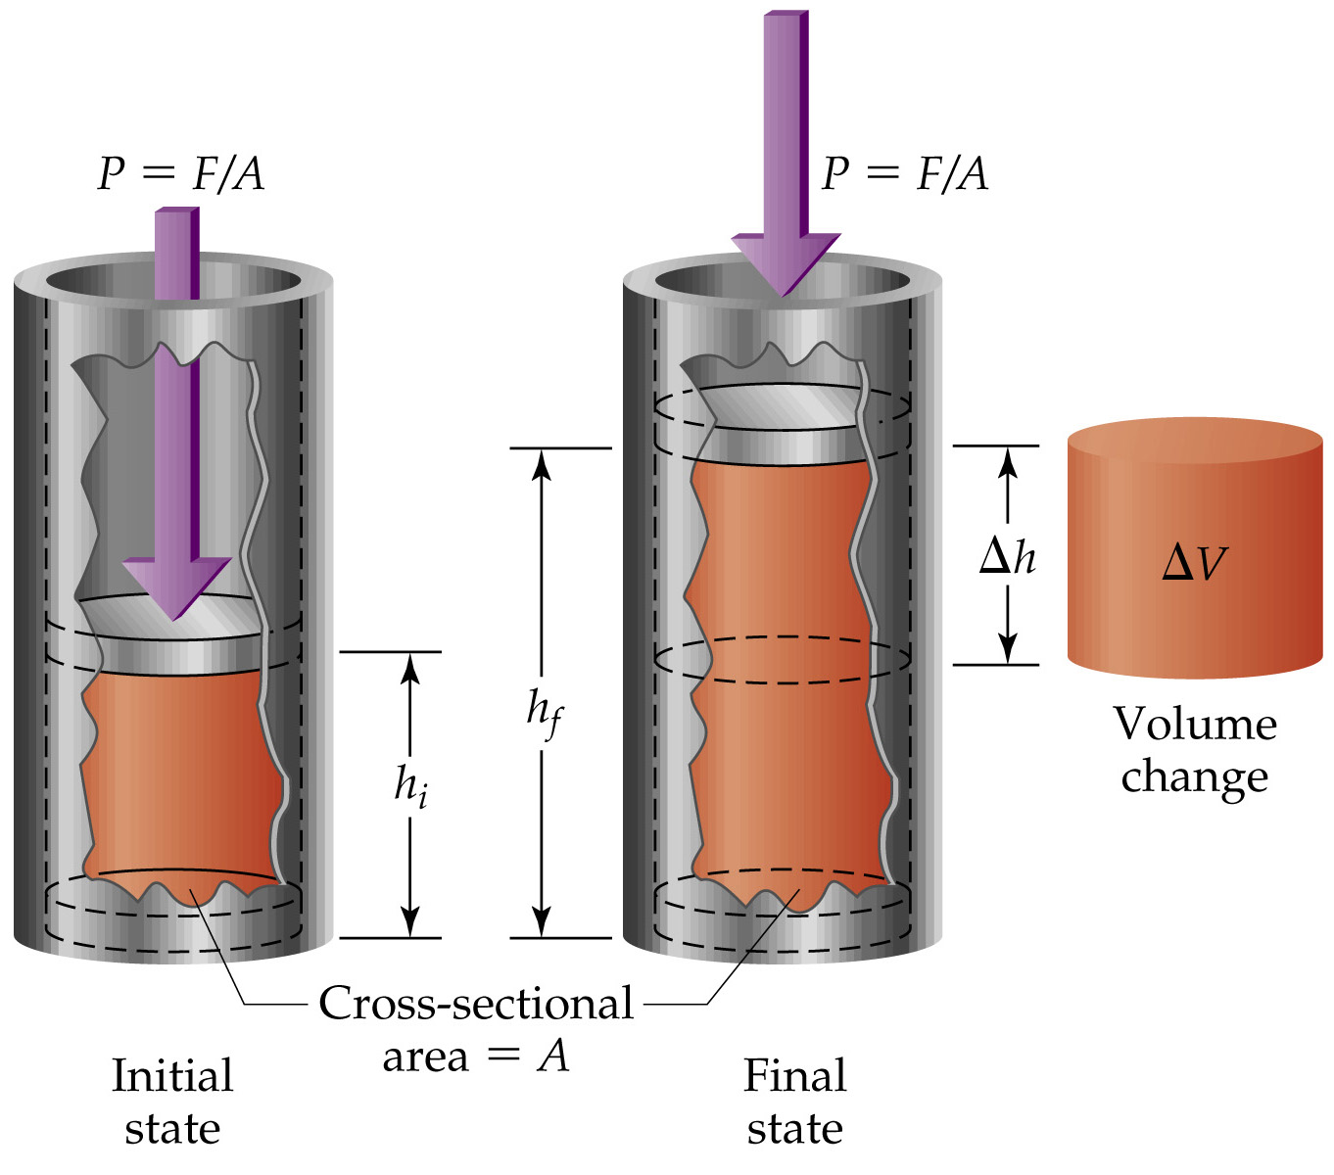
A cylinder of cross-sectional area A, A piston exerting a pressure, P = F/A, on a gas inside the cylinder
The volume of gas expanding through ΔV while the piston moves a height Δh = hf – hi.
The magnitude of work done =
F x Δh = P x A x Δh = P x ΔV.
Since work is being done by the system on the surroundings, w = –PΔV.
Using the first law of thermodynamics,
ΔE = q + w = q – PΔV.
If the reaction is carried out under constant volume,
ΔV = 0 thus ΔE = q_{v}.
ΔH = ΔE + PΔV= ΔE = q_{v}.

If the reaction is carried out under constant pressure,
ΔE = q_{p} – PΔV
Since ΔH = ΔE + PΔV by definition and substituting
ΔH= q_{p}
or ΔE = ΔH – PΔV

