State Functions

A state function depends only on the initial & final states of a system.

EXAMPLES:
Altitude: The altitude difference between Denver and Chicago does not depend on whether you fly or drive, only on the elevation of the two cities above sea level.

Internal Energy: Similarly, the internal energy of 50 g of H₂O(l) at 25□C does not depend on whether we cool 50 g of H₂O(l) from 100□C to 25□C or heat 50 g of H₂O(l) at 0□C to 25□C.

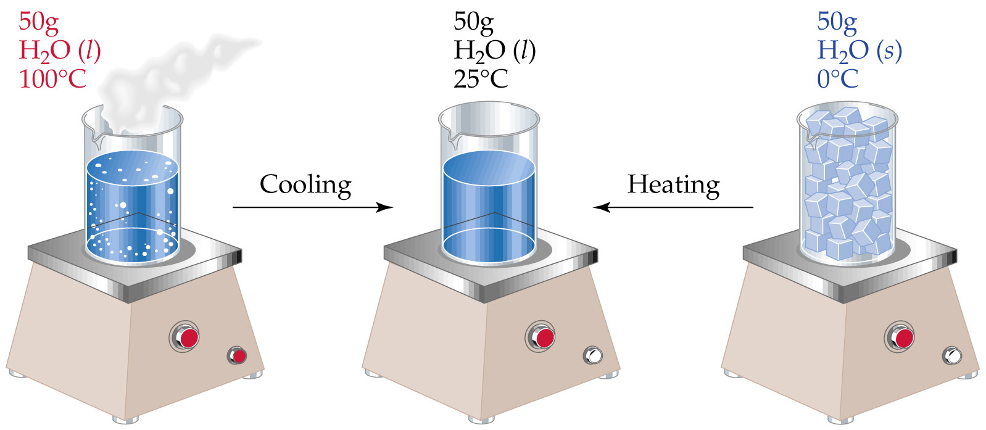

A state function does not depend on how the internal energy is used.

EXAMPLE:
A battery in a flashlight can be discharged by producing heat and light. The same battery in a toy car is used to produce heat and work. The change in internal energy of the battery is the same in both cases
