The Nature of Energy

Thermodynamics is the study of energy and its transformations.

Thermochemistry is the study of the relationships between chemical reactions and energy changes involving heat.
Kinetic Energy and Potential Energy
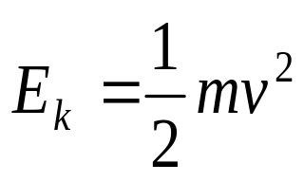Kinetic energy is the energy of motion:

Potential energy is the energy an object possesses by virtue of its position or composition.
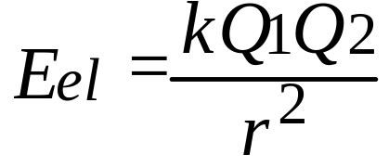 • Electrostatic energy is an example

It arises from interactions between charged particles.

Potential energy can be converted into kinetic energy.
Example: A ball of clay dropped off a building.

Units of Energy

SI unit is the joule, J.
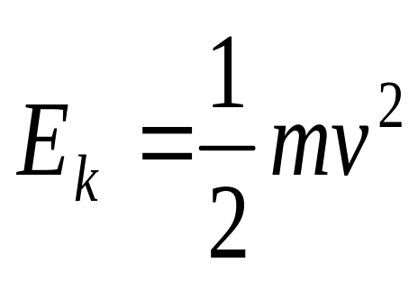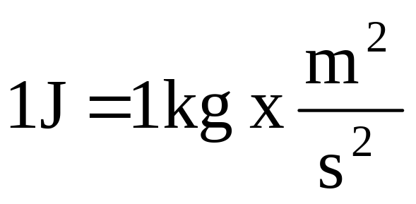

Traditionally, we use the calorie as a unit of energy.

1 cal = 4.184 J (exactly)

The nutritional Calorie, Cal = 1,000 cal.

