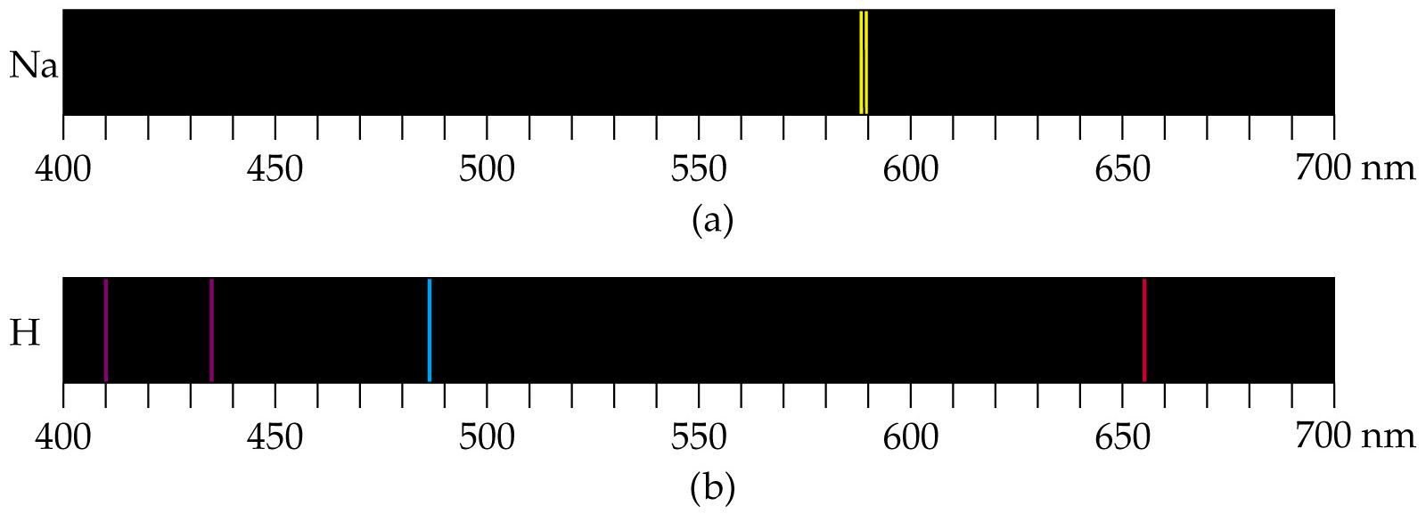
Bohr Model
Colors from excited gases arise because electrons move between energy states in the atom.

Line Spectra and the Bohr Model

