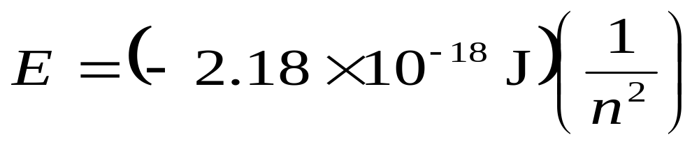
Line Spectra and the Bohr Model
Bohr Model
- Since the energy states are quantized, the light emitted from excited atoms must be quantized and appear as line spectra.
- Using the Rydberg Equation and converting wavelength to Energy , Bohr showed that

where n is the principal quantum number
(i.e., n = 1, 2, 3, … and nothing else).

