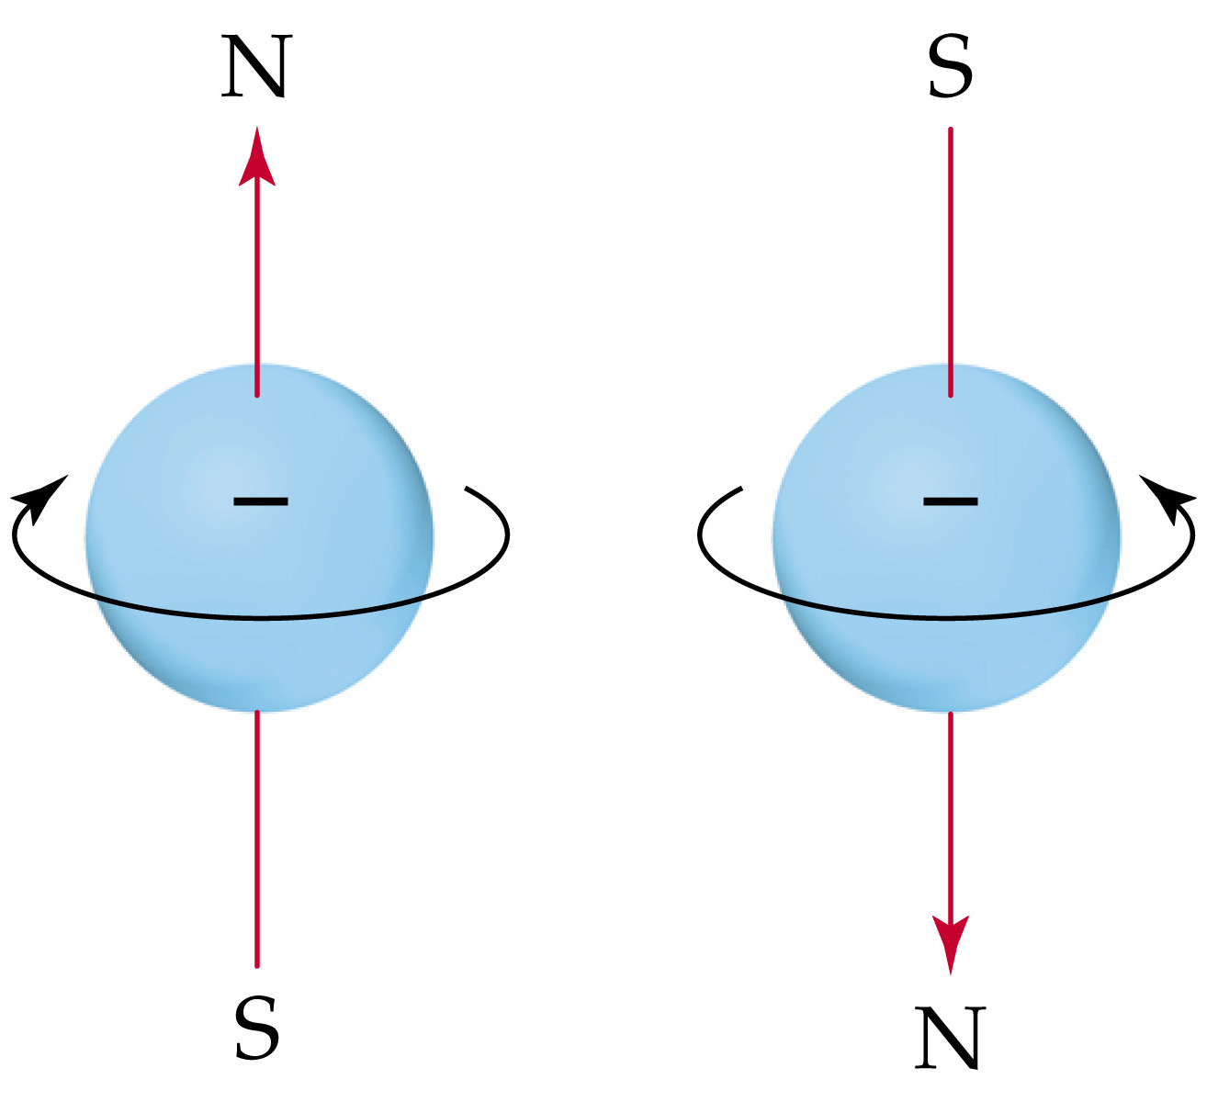
Electron Spin and the Pauli Exclusion Principle
Many-Electron Atoms

