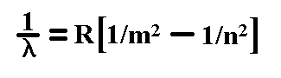
Line Spectra and the Bohr Model
Line Spectra
- Balmer: discovered that the lines in the visible line spectrum of hydrogen fit a simple equation.
- Later Rydberg generalized Balmer’s equation to:

where R is the Rydberg constant (1.096776 × 10⁷ m⁻¹), , m and n are integers (n(from) > m(to)).
If m = 1 Lyman Series m = 2 Balmer Series m = 3 Paschen Series

