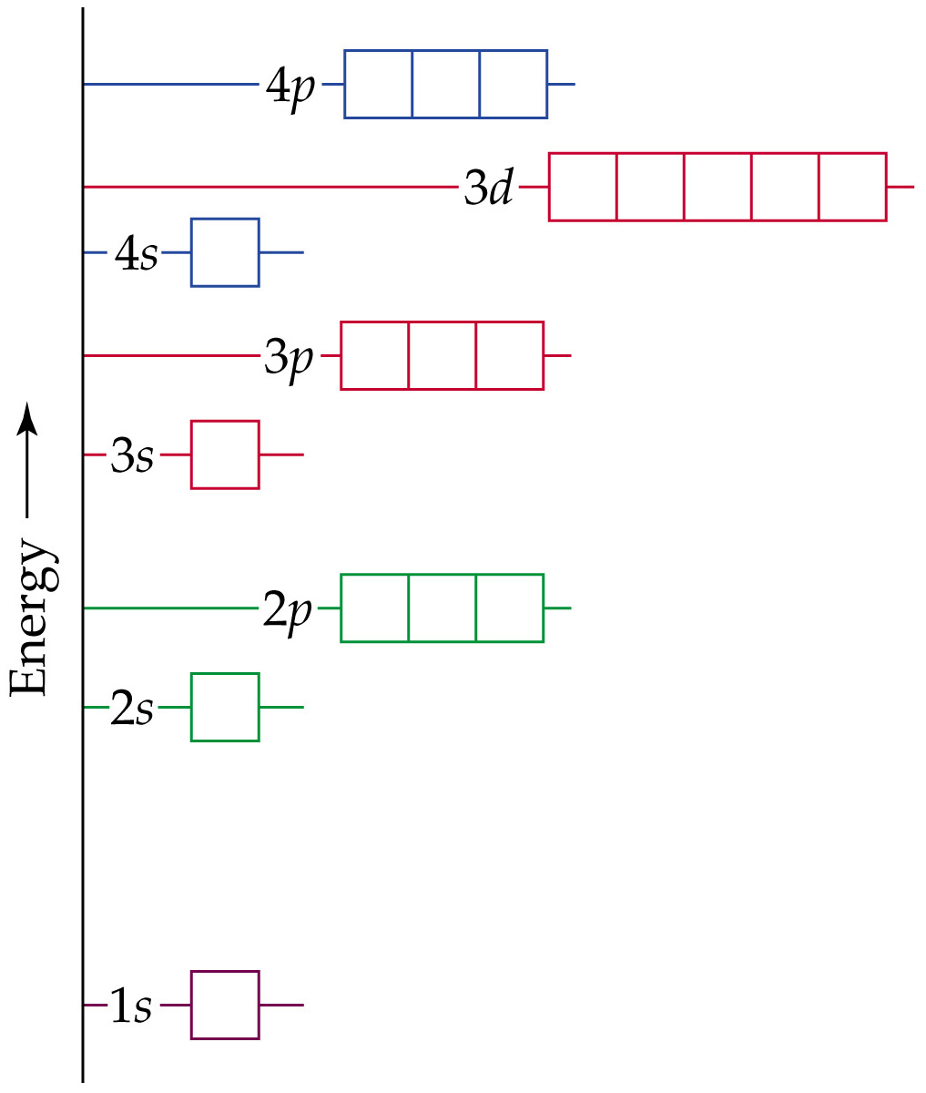
Many-Electron Atoms
Orbitals and Their Energies

