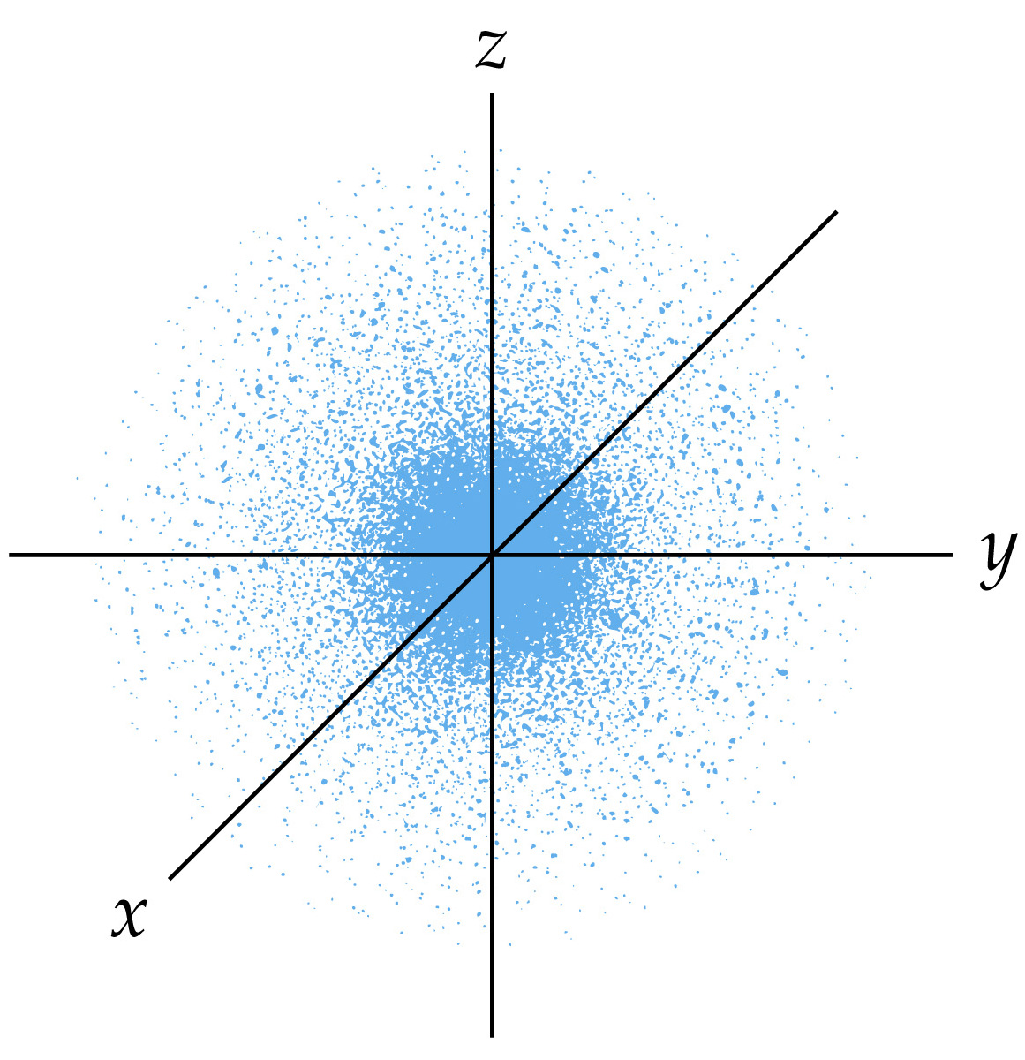
Quantum Mechanics and Atomic Orbitals

