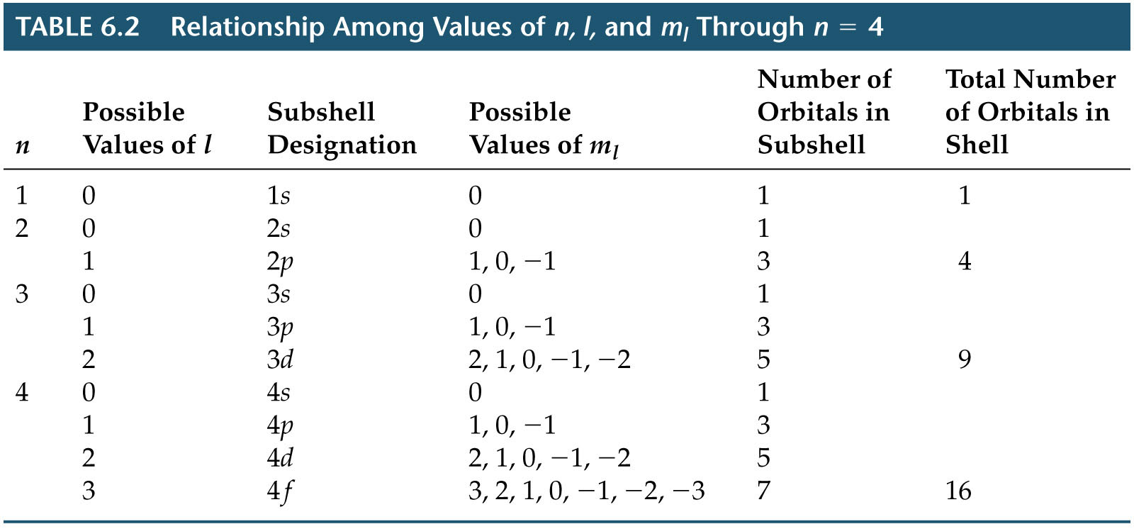
Orbitals and Quantum Numbers

Quantum Mechanics and Atomic Orbitals

