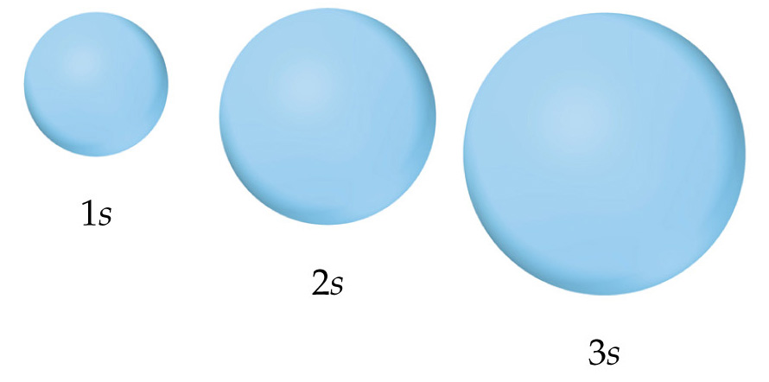
The s-Orbitals
Representations of Orbitals

