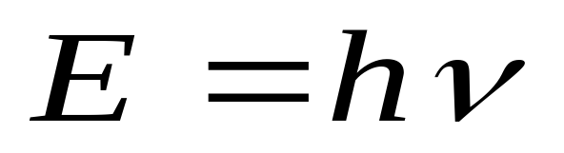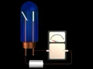
The Photoelectric Effect and Photons
Einstein assumed that light traveled in energy packets called photons.
The energy of one photon:

Quantized Energy and Photons

