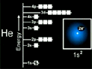
Transition Metals

After Ar the d orbitals begin to fill.
After the 3d orbitals are full, the 4p orbitals being to fill.
Transition metals: elements in which the d electrons are the valence electrons.
Electron Configurations

