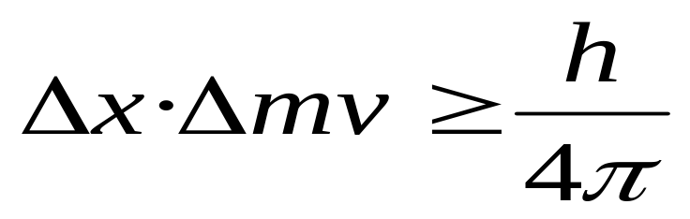
Heisenberg’s Uncertainty Principle: on the mass scale of atomic particles, we cannot determine exactly the position, direction of motion, and speed simultaneously.
For electrons: we cannot determine their momentum and position simultaneously.
If Δx is the uncertainty in position and Δmv is the uncertainty in momentum, then
The Wave Behavior of Matter

