Wave Nature of Electron
As a young student at the University of Paris, Louis DeBroglie had been impacted by relativity and the photoelectric effect, both of which had been introduced in his lifetime. The photoelectric effect pointed to the particle properties of light, which had been considered to be a wave phenomenon. He wondered if electons and other "particles" might exhibit wave properties. The application of these two new ideas to light pointed to an interesting possibility:
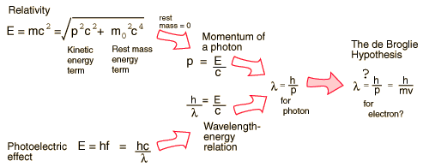

h = 6.626 x 10⁻³⁴ J sec
c = 2.98 x 10⁸ m/sec

Confirmation of the DeBroglie hypothesis came in the Davisson- Germer experiment.

Example for Typical Electron

λ = h/(mv) 6.626 x 10⁻³⁴/(9.109 x 10⁻³¹ kg * 0.5*3.0 x 10⁸ m/sec)
4.85x10⁻¹² m or 0.0485 Aº ~ 1/20 of Aº

