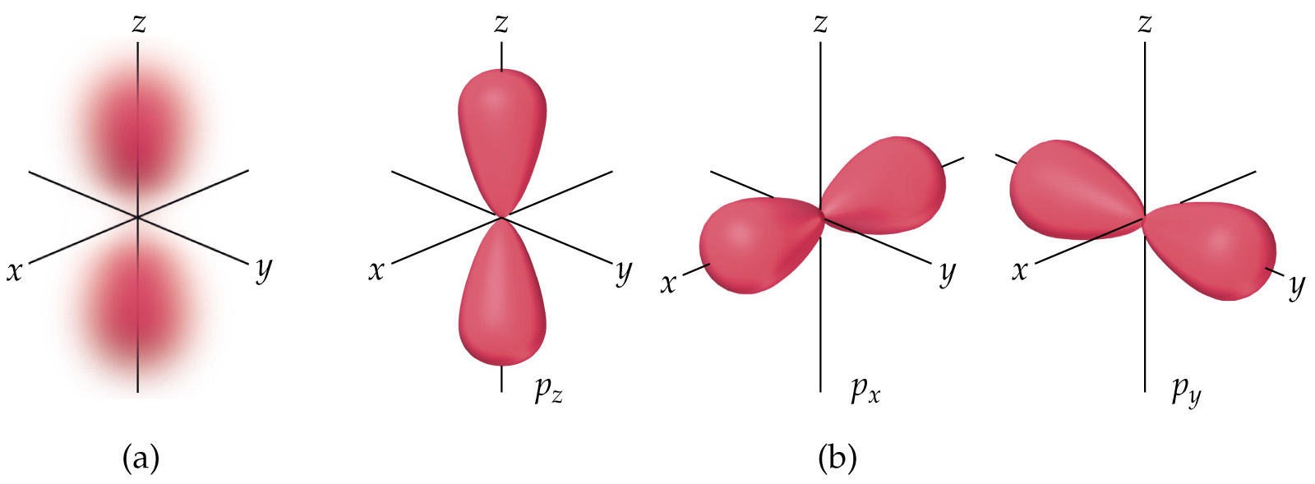
The p-Orbitals

Representations of Orbitals

