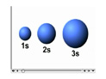

All s-orbitals are spherical.
As n increases, the s-orbitals get larger.
As n increases, the number of nodes increase.
A node is a region in space where the probability of finding an electron is zero.
At a node, Ψ² = 0
For an s-orbital, the number of nodes is (n - 1).
Representations of s-Orbitals

