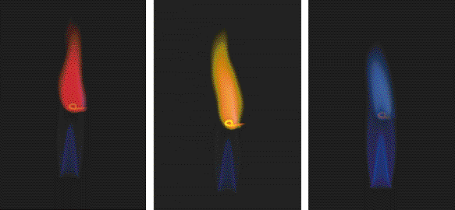
Na line (589 nm): 3p → 3s transition
Li line: 2p → 2s transition
K line: 4p → 4s transition
Group 1A: The Alkali Metals

