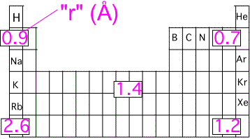

Approximate Atomic Size TRENDS across the Periodic Table

